2018/12/27
當日市場：儘管勢頭不斷下跌外資仍繼續買超
市場走勢 2018/12/26
市場指數 | VNI | HNI | UPCOM
收盤 | 891.75 | 102.28 | 52.19
%日 | -0.69% | -0.16% | 0.60%
%週 | -3.16% | -1.90% | -1.39%
%月 | -2.18% | -1.76% | 0.02%
%年 | -6.30% | -9.53% | -4.44%
成交值(十億盾)
當日 | 4,976 | 741 | 288
日均量/週 | 4,112 | 831 | 395
日均量/月 | 4,144 | 613 | 333
外資進出
買進 | 515.51 | 7.46 | 57.21
賣出 | 419.06 | 9.73 | 24.68
買賣超 | 96.45 | (2.27) | 32.53
市場漲跌家數
上漲 | 137 | 88 | 88
下跌 | 136 | 63 | 73
持平 | 111 | 231 | 695
市場指標
P/E | 15.6x | 9.5x | 15.1x
總市值 | 2,899 | 143 | 923
(兆盾)
股息殖利率 | 2.63% | 3.95% | 3.85%
資料源: Bloomberg – YSVN

VNINDEX

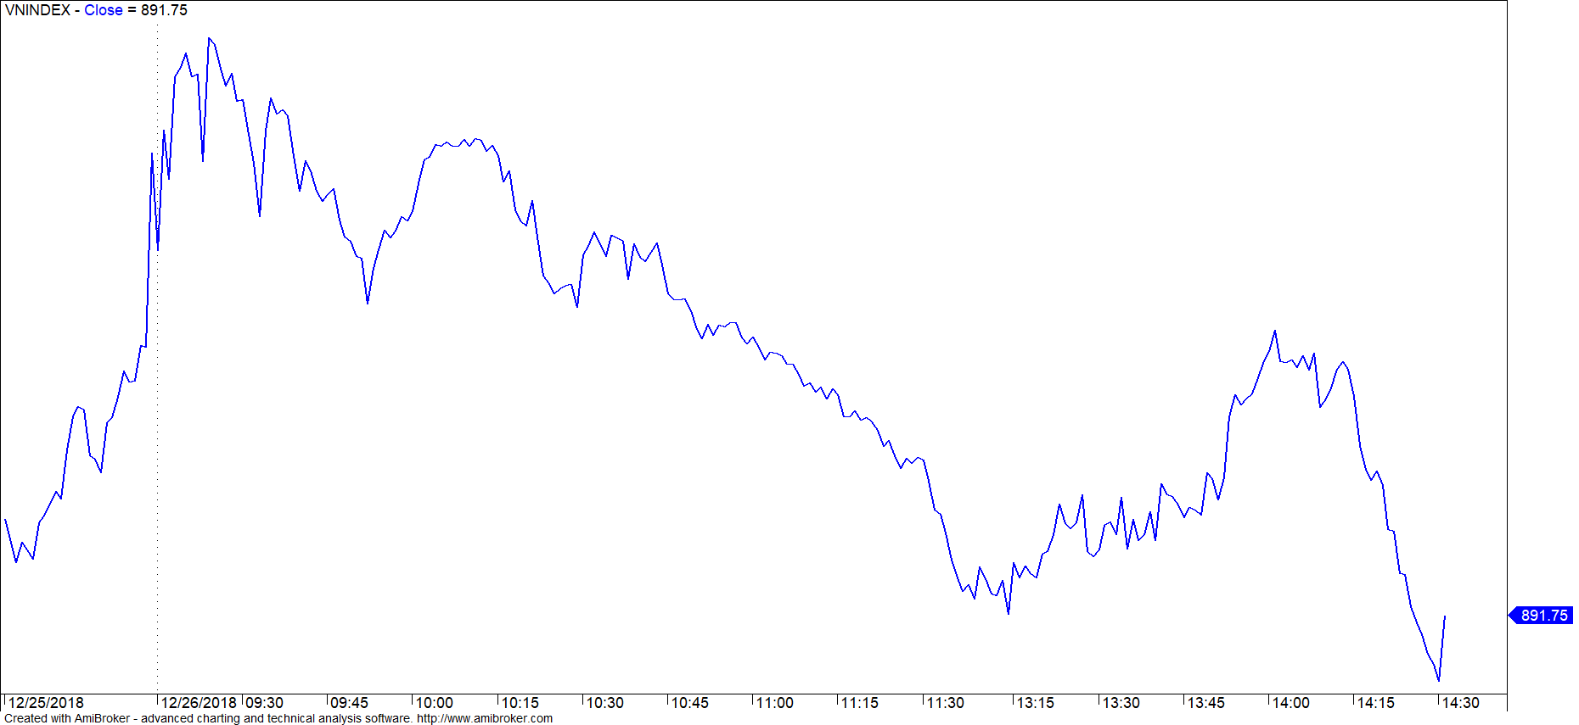

HNXINDEX

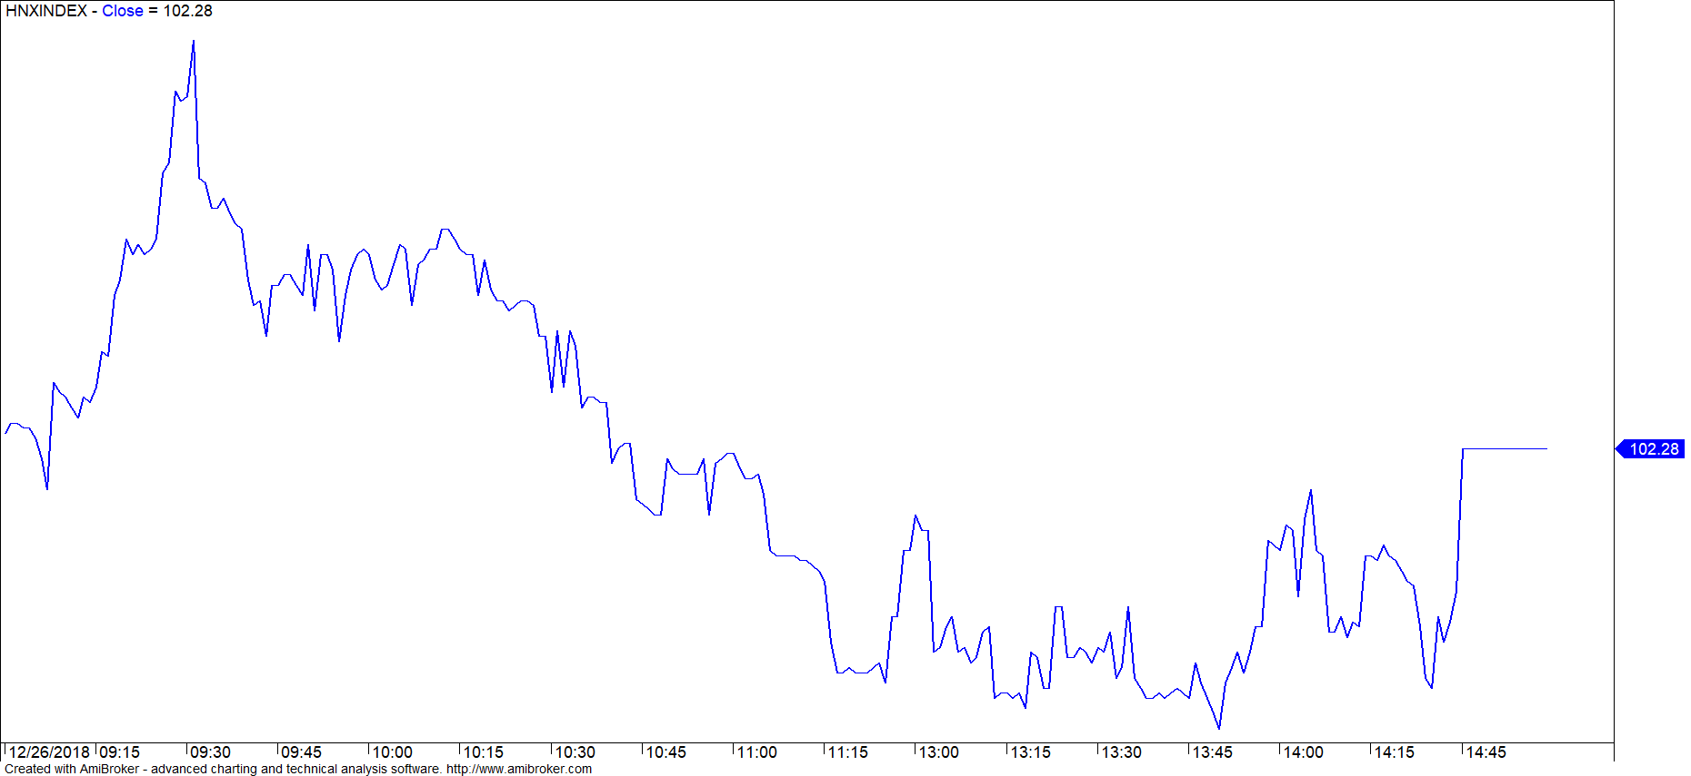

市場走勢
亞洲市場交投沒有太大波動，但盤中下跌的市場仍佔多數。 自今年年初至今，年終交易對市場交投並不太積極。
市場 | 最高 52w | 最低 52w | 差值 | 一年漲跌
中國 | 3,587 | 2,449 | -31.73% | -23.65%
日本 | 24,448 | 19,117 | -21.81% | -15.26%
香港 | 33,484 | 24,540 | -26.71% | -13.28%
韓國 | 2,607 | 1,985 | -23.86% | -16.55%
泰國 | 1,852 | 1,548 | -16.41% | -11.06%
越南 | 1,211 | 880 | -27.33% | -6.30%
今年，越南市場宏觀經濟的穩定大大支撐了不少領域包括股票在內，目前市場仍受到國際政治經濟不穩定的影響，對市場和投資者心理產生負面影響。盤終，VN-Index收報891點，下跌0.69％，HNX指數窄幅交易在平盤位附件，略微下跌0.16％。GAS繼續成為股指的主要影響因素，另，VHM，CTG，TCB，PVS，VCG等股碼也使股指無法脫離跌勢。
外資當日買超約1260億越盾，主要集中在 HSX和Upcom盤。擁有大量買超的股票有：CTD，HPG，KDH，VEA，BID。相反，E1VFVN30基金劵以及VHM，CTD，PVD，PNJ繼續遭拋售。

市場評論
我們預計未來數盤市場可能仍會在VN-Index的897點左右波動。同時，價格圖表仍有可能出現技術性反彈，但反方向的跡象仍未明確，因此，短期風險仍偏高。積極點是，市場出現的表面紅跌但內會綠漲，意味著投資者心態對當前形勢並不過於悲觀。此外，股票比例持續降低，表明短期策略仍是優先降低庫存比例。
我們的趨勢指標仍維持兩大股指短期趨勢下跌，阻力區止損位於VN-Index的914.62點，和HNX指數的106.14點。因此，我們建議短線投資者在下跌期間限制拋售，並將股票比例調到建議比例。
建議短期投資比重：22% 股票 / 78% 現金
(股票趨勢追踪圖在下一頁內更新).

技術分析圖

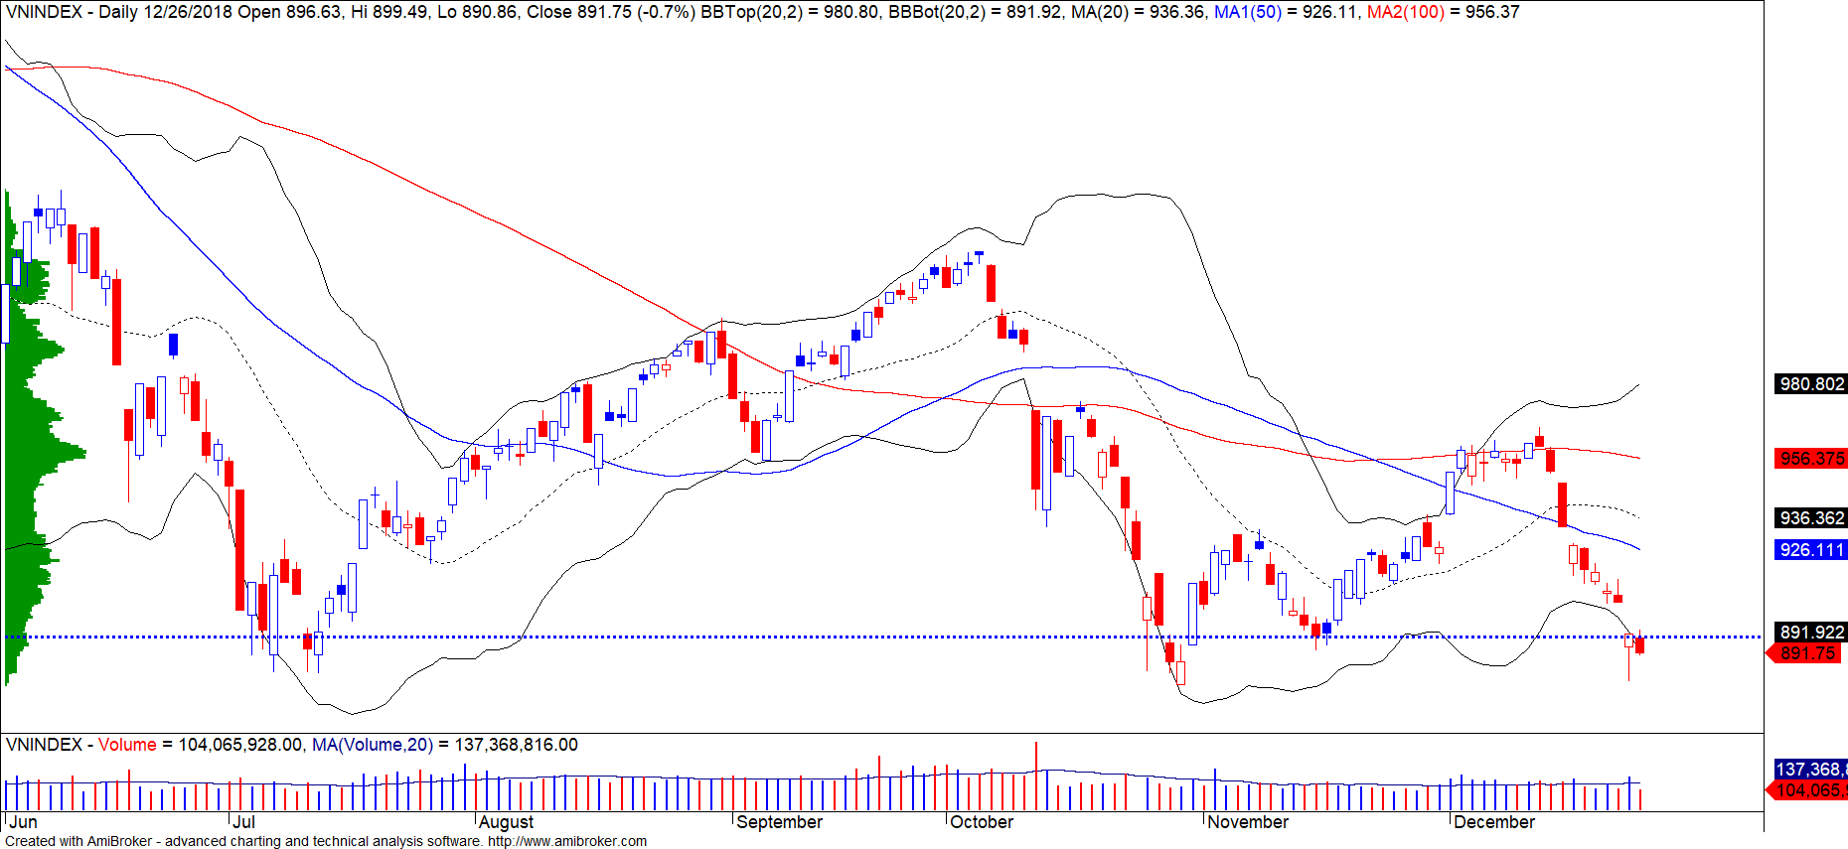
指數技術分析圖 VN-Index

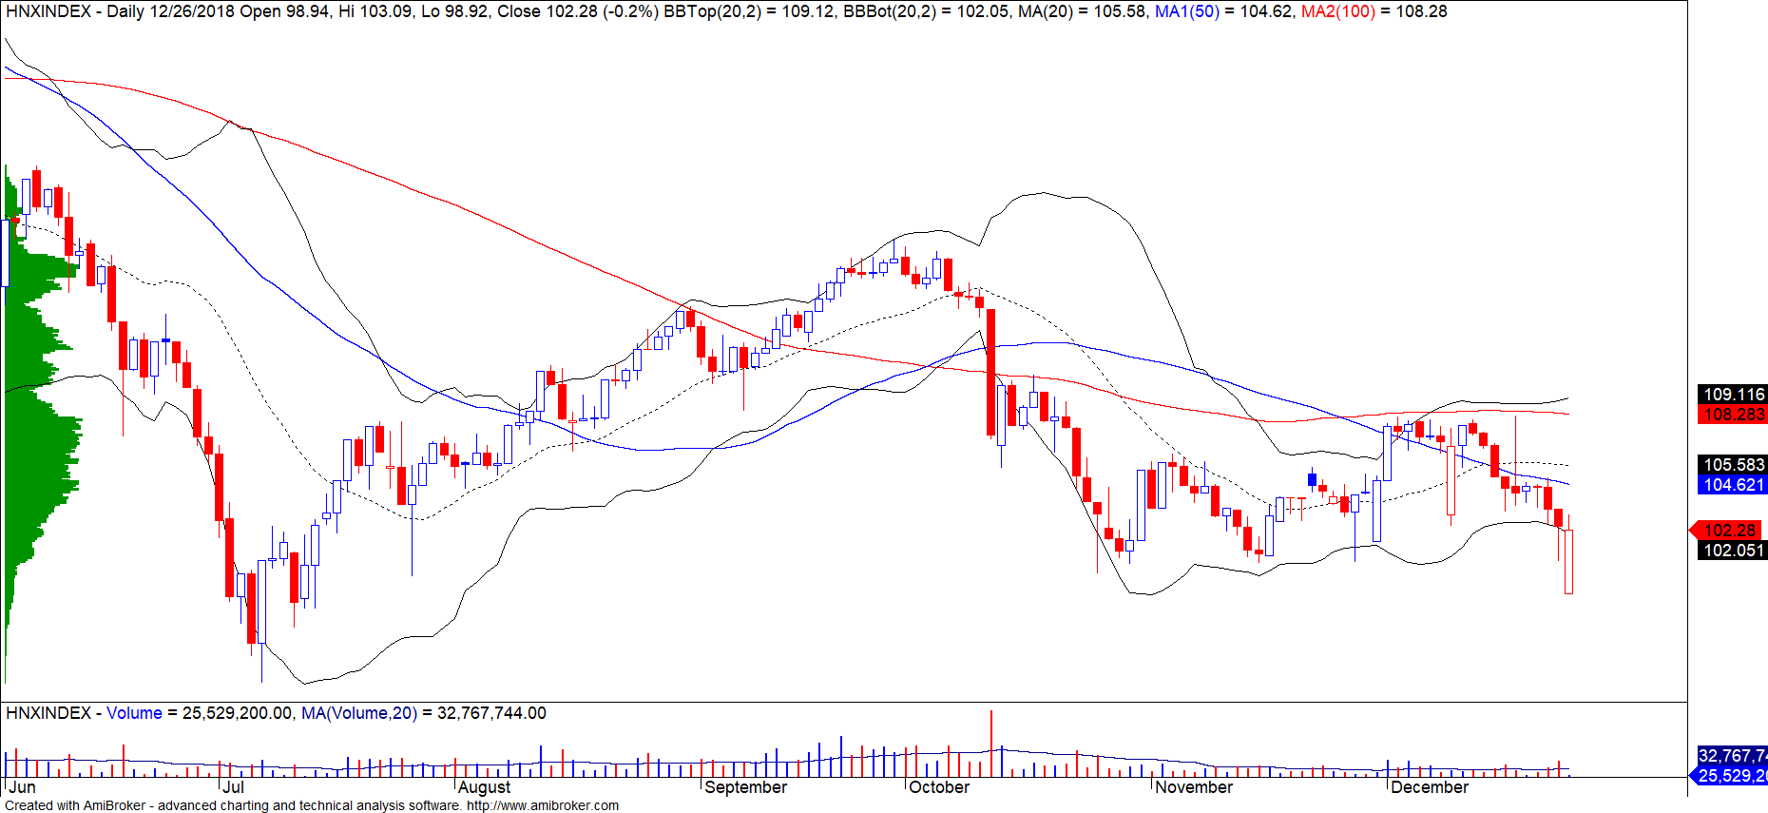
指數技術分析圖 HNX-Index

指數 | 短期趨勢 | 中期趨勢 | 阻力區 1 | 阻力區2 | 支撐區 1 | 支撐區2
VN-Index | 下跌 | 下跌 | 972 | 1,025 | 897 | 780
HNX-Index | 下跌 | 下跌 | 110 | 117 | 100 | 96
VN30 | 下跌 | 下跌 | 946 | 995 | 865 | 768
VNMidcaps | 下跌 | 下跌 | 1,020 | 1,079 | 925 | 971
VNSmallcaps | 下跌 | 下跌 | 815 | 835 | 789 | 769
股票趨勢追蹤表

股票 | 價格 | 短期  趨勢 | 中期  趨勢 | 短期  買進價 | 短期止損 | 暫計短期利潤% | 短期訊號 | 中期  買進價 | 中期止損 | 暫計中期獲利% | 中期訊號
AAA | 14,500 | 下跌 | 下跌 |  | 15,390 |  |  |  | 16,612
ACB | 28,700 | 下跌 | 下跌 |  | 30,626 |  |  |  | 33,291
ACV | 83,700 | 上漲 | 下跌 | 81,800 | 81,307 | 2.32% |  |  | 86,919
ANV | 28,450 | 下跌 | 上漲 |  | 30,830 |  |  | 21,450 | 25,326 | 32.63%
ASM | 8,400 | 下跌 | 下跌 |  | 9,643 |  |  |  | 12,065
BFC | 25,150 | 下跌 | 下跌 |  | 26,694 |  |  |  | 26,729
BHN | 82,300 | 下跌 | 下跌 |  | 84,327 |  |  |  | 95,267
BID | 32,600 | 下跌 | 上漲 | 32,450 | 32,686 | 0.73% | 賣出 | 33,400 | 29,888 | -2.40%
BMP | 51,700 | 下跌 | 下跌 |  | 55,267 |  |  |  | 62,972
BSR | 13,200 | 下跌 | 下跌 |  | 14,446 |  |  |  | 18,175
BVH | 90,700 | 下跌 | 上漲 |  | 97,014 |  |  | 86,000 | 88,082 | 5.47%
BWE | 25,000 | 上漲 | 上漲 | 20,900 | 24,140 | 19.62% |  | 20,000 | 22,129 | 25.00%
CEO | 12,700 | 下跌 | 下跌 |  | 14,032 |  |  |  | 14,906
CHP | 21,000 | 下跌 | 下跌 |  | 21,433 |  |  |  | 22,586
CSM | 14,850 | 下跌 | 上漲 |  | 15,158 |  |  | 14,390 | 13,911 | 3.19%
CTD | 158,000 | 上漲 | 下跌 | 151,500 | 155,155 | 4.29% |  |  | 164,807
CTG | 19,300 | 下跌 | 下跌 |  | 21,107 |  |  |  | 25,893
CTI | 23,700 | 上漲 | 下跌 | 24,400 | 23,466 | -2.87% |  |  | 26,512
CVT | 19,450 | 下跌 | 下跌 |  | 20,523 |  |  |  | 26,095
DCM | 10,400 | 上漲 | 下跌 | 10,500 | 9,734 | -0.95% |  |  | 10,704
DGW | 22,800 | 下跌 | 下跌 |  | 24,136 |  |  | 27,500 | 23,622 | -14.10% | 賣出
DHA | 30,600 | 上漲 | 上漲 | 30,300 | 29,997 | 0.99% |  | 29,100 | 27,521 | 5.15%
DIG | 14,500 | 下跌 | 下跌 |  | 15,608 |  |  |  | 17,064
DHC | 30,600 | 下跌 | 上漲 |  | 32,258 |  |  | 44,600 | 29,901 | -31.39%
DHG | 75,700 | 下跌 | 下跌 |  | 79,114 |  |  |  | 92,119
DGC | 44,700 | 下跌 | 下跌 |  | 47,485 |  |  |  | 52,481
DPG | 50,300 | 上漲 | 上漲 | 48,250 | 48,603 | 4.25% |  | 52,000 | 42,258 | -3.27%
DPM | 22,700 | 上漲 | 上漲 | 18,800 | 20,808 | 20.74% |  | 19,400 | 18,719 | 17.01%
DPR | 31,500 | 下跌 | 上漲 |  | 32,904 |  |  | 35,950 | 30,450 | -12.38%
DQC | 26,750 | 下跌 | 上漲 |  | 27,352 |  |  | 31,000 | 26,186 | -13.71%
DRC | 20,500 | 下跌 | 下跌 |  | 21,896 |  |  |  | 24,626
DXG | 23,000 | 下跌 | 下跌 |  | 24,766 |  |  |  | 29,079
ELC | 7,680 | 下跌 | 下跌 |  | 7,767 |  |  |  | 8,913
FCN | 15,000 | 下跌 | 上漲 |  | 15,748 |  |  | 17,700 | 14,479 | -15.25%
FIT | 2,520 | 下跌 | 下跌 |  | 2,751 |  |  |  | 3,581
FMC | 29,000 | 下跌 | 上漲 |  | 30,129 |  |  | 24,700 | 26,427 | 17.41%
FPT | 41,400 | 下跌 | 下跌 |  | 42,788 |  |  |  | 46,495
GAS | 83,000 | 下跌 | 下跌 |  | 90,626 |  |  |  | 108,844
GEX | 22,700 | 下跌 | 下跌 |  | 24,143 |  |  |  | 28,690
GIL | 33,500 | 下跌 | 下跌 |  | 35,902 |  |  | 34,900 | 34,848 | -0.15%
GMD | 26,100 | 下跌 | 上漲 |  | 27,659 |  |  | 27,300 | 25,612 | -4.40%
GTN | 10,050 | 下跌 | 下跌 |  | 10,395 |  |  |  | 11,796
HAG | 4,880 | 下跌 | 下跌 |  | 5,211 |  |  |  | 6,172
HAX | 15,900 | 下跌 | 下跌 |  | 16,391 |  |  |  | 18,209
HBC | 17,200 | 下跌 | 下跌 |  | 18,944 |  |  |  | 22,353
HDB | 28,800 | 下跌 | 下跌 |  | 30,021 |  |  |  | 35,217
HNG | 15,650 | 下跌 | 上漲 |  | 16,156 |  |  | 8,200 | 14,502 | 90.85%
HPG | 30,300 | 下跌 | 下跌 |  | 31,743 |  |  |  | 38,366
HSG | 5,960 | 下跌 | 下跌 |  | 6,934 |  |  |  | 9,322
HT1 | 13,500 | 下跌 | 上漲 |  | 14,633 |  |  | 14,800 | 12,654 | -8.78%
HUT | 4,000 | 下跌 | 下跌 |  | 4,450 |  |  |  | 5,267
HVN | 32,900 | 下跌 | 下跌 |  | 33,732 |  |  |  | 37,369
ITD | 10,500 | 下跌 | 上漲 |  | 11,212 |  |  | 12,400 | 10,106 | -15.32%
KBC | 13,300 | 下跌 | 上漲 |  | 14,594 |  |  | 13,450 | 12,358 | -1.12%
KDH | 31,450 | 上漲 | 下跌 | 29,500 | 30,183 | 6.61% |  |  | 32,650
KSB | 25,800 | 下跌 | 下跌 |  | 26,380 |  |  |  | 32,224
LCG | 7,990 | 下跌 | 下跌 |  | 8,196 |  |  |  | 9,392
LDG | 14,000 | 下跌 | 下跌 |  | 15,590 |  |  |  | 18,940
LIX | 47,200 | 下跌 | 上漲 |  | 50,124 |  |  | 44,400 | 45,486 | 6.31%
LPB | 9,500 | 下跌 | 下跌 |  | 9,645 |  |  |  | 10,601
LSS | 6,650 | 上漲 | 上漲 | 7,000 | 6,255 | -5.00% |  | 7,890 | 6,353 | -15.72%
MBB | 19,600 | 下跌 | 下跌 |  | 20,768 |  |  |  | 23,846
MPC | 39,000 | 下跌 | 下跌 |  | 42,957 |  |  | 46,700 | 40,579 | -13.11%
MSN | 79,000 | 下跌 | 下跌 |  | 83,158 |  |  |  | 90,176
MSR | 19,400 | 下跌 | 上漲 |  | 21,005 |  |  | 19,884 | 17,887 | -2.43%
MWG | 85,400 | 下跌 | 下跌 |  | 87,875 |  |  |  | 92,518
NKG | 7,770 | 上漲 | 下跌 | 8,130 | 7,730 | -4.43% |  |  | 10,241
NLG | 25,000 | 下跌 | 下跌 |  | 26,907 |  |  |  | 31,565
NT2 | 25,050 | 下跌 | 下跌 | 24,900 | 25,182 | 1.13% | 賣出 |  | 26,612
NTL | 18,300 | 上漲 | 上漲 | 10,000 | 17,066 | 83.00% |  | 10,450 | 14,609 | 75.12%
NTP | 41,000 | 下跌 | 下跌 |  | 42,239 |  |  |  | 49,006
PAC | 38,600 | 下跌 | 下跌 |  | 40,597 |  |  | 44,100 | 39,941 | -9.43% | 賣出
PC1 | 24,450 | 上漲 | 下跌 | 23,500 | 23,171 | 4.04% |  |  | 25,195
PDR | 25,600 | 下跌 | 下跌 |  | 26,748 |  |  |  | 28,768
PGC | 14,200 | 下跌 | 下跌 |  | 14,613 |  |  |  | 15,410
PHR | 31,800 | 上漲 | 上漲 | 29,300 | 30,442 | 8.53% |  | 24,000 | 26,164 | 32.50%
PNJ | 93,500 | 下跌 | 上漲 |  | 97,827 |  |  | 103,900 | 91,800 | -10.01%
PLX | 55,200 | 下跌 | 下跌 |  | 58,303 |  |  |  | 66,270
POW | 14,900 | 上漲 | 下跌 | 14,300 | 14,596 | 4.20% |  |  | 16,115
PPC | 17,750 | 下跌 | 上漲 |  | 18,412 |  |  | 19,700 | 16,537 | -9.90%
PTB | 59,500 | 下跌 | 上漲 |  | 62,731 |  |  | 64,000 | 56,808 | -7.03%
PVS | 17,100 | 下跌 | 下跌 |  | 18,728 |  |  |  | 22,123
PVD | 14,300 | 下跌 | 下跌 |  | 15,639 |  |  |  | 19,341
PVI | 32,700 | 上漲 | 上漲 | 32,900 | 30,946 | -0.61% |  | 33,000 | 30,008 | -0.91%
PXS | 5,040 | 下跌 | 下跌 |  | 5,281 |  |  |  | 6,221
QNS | 42,400 | 下跌 | 上漲 |  | 43,693 |  |  | 41,500 | 2,557 | 2.17%
RAL | 83,000 | 下跌 | 下跌 |  | 87,348 |  |  |  | 96,701
REE | 30,700 | 下跌 | 下跌 |  | 31,767 |  |  |  | 34,681
SAB | 249,000 | 上漲 | 上漲 | 208,000 | 241,072 | 19.71% |  | 245,000 | 224,954 | 1.63%
SAM | 6,900 | 上漲 | 下跌 | 7,090 | 6,624 | -2.68% |  |  | 7,361
SBV | 14,700 | 下跌 | 下跌 |  | 15,334 |  |  |  | 18,710
SCR | 7,600 | 下跌 | 下跌 |  | 7,726 |  |  |  | 8,940
SHI | 6,580 | 上漲 | 上漲 | 6,680 | 6,342 | -1.50% |  | 6,990 | 5,879 | -5.87%
SJS | 18,600 | 上漲 | 上漲 | 16,400 | 16,999 | 13.41% |  | 18,100 | 17,846 | 2.76% | 買進
SKG | 17,850 | 上漲 | 下跌 | 17,450 | 17,225 | 2.29% |  |  | 19,471
SSI | 26,650 | 下跌 | 下跌 |  | 27,641 |  |  |  | 32,215
STB | 11,950 | 下跌 | 下跌 |  | 12,478 |  |  |  | 13,932
SVC | 42,500 | 下跌 | 下跌 |  | 44,520 |  |  |  | 47,578
TCB | 26,000 | 下跌 | 下跌 |  | 27,573 |  |  |  | N/A
TCM | 22,200 | 下跌 | 下跌 |  | 24,044 |  |  |  | 29,332
TDH | 9,980 | 下跌 | 下跌 |  | 10,584 |  |  |  | 11,745
TLH | 5,700 | 下跌 | 下跌 |  | 5,964 |  |  |  | 6,641
TMT | 9,000 | 下跌 | 上漲 |  | 9,524 |  |  | 9,290 | 8,746 | -3.12%
TNG | 16,700 | 下跌 | 上漲 |  | 18,175 |  |  | 12,000 | 15,302 | 39.17%
TYA | 10,600 | 上漲 | 下跌 | 10,900 | 10,238 | -2.75% |  |  | 11,557
VCB | 52,800 | 下跌 | 下跌 |  | 54,668 |  |  |  | 61,169
VCG | 23,100 | 上漲 | 上漲 | 20,300 | 22,275 | 13.79% |  | 19,200 | 16,962 | 20.31%
VFG | 39,000 | 下跌 | 上漲 |  | 39,075 |  |  | 34,394 | 34,815 | 13.39%
VGC | 18,300 | 上漲 | 下跌 | 16,300 | 17,391 | 12.27% |  |  | 18,454
VHC | 91,700 | 下跌 | 上漲 |  | 96,310 |  |  | 69,300 | 91,531 | 32.32% | 賣出
VHM | 72,000 | 下跌 | 上漲 |  | 77,144 |  |  | 80,000 | 68,839 | -10.00%
VIB | 17,800 | 下跌 | 下跌 |  | 18,941 |  |  |  | 21,285
VIC | 101,900 | 上漲 | 下跌 | 96,400 | 99,549 | 5.71% |  |  | 104,386
VIP | 6,800 | 下跌 | 下跌 |  | 7,156 |  |  |  | 7,294
VJC | 122,000 | 下跌 | 下跌 |  | 126,191 |  |  |  | 145,748
VNM | 124,000 | 下跌 | 上漲 |  | 129,121 |  |  | 133,900 | 121,088 | -7.39%
VPB | 19,500 | 下跌 | 下跌 |  | 21,017 |  |  |  | 24,014
VPI | 42,000 | 下跌 | N/A |  | 42,912 |  |  |  | 6,177
VRC | 18,500 | 下跌 | 下跌 |  | 20,081 |  |  | 19,350 | 20,785 | 7.42% | 賣出
VRE | 29,200 | 下跌 | 下跌 |  | 30,880 |  |  |  | 34,506
VSC | 40,000 | 下跌 | 下跌 |  | 43,299 |  |  |  | 45,128
VSH | 16,900 | 上漲 | 上漲 | 17,400 | 16,731 | -2.87% |  | 17,400 | 16,642 | -2.87%

胡志明市交易所 (HSX) |  |  |  | 河內交易所 (HSX) |  |  |  | UPCOM市場 (UPCoM)
 | 收盤 | 漲跌% |  |  | 收盤 | 漲跌% |  |  | 收盤 | 漲跌%
VNI | 897.94 | -1.17% |  | HNI | 102.44 | -0.87% |  | UPCoM | 51.88 | -1.11%
VN30 | 865.69 | -0.91% |  | HN30 | 186.15 | -1.51%
VN Mid | 921.80 | -1.86% |  | VNX AllSh | 826.96 | -1.07%
VN Small | 774.64 | -1.32%
外資交易 | 成交值(十億盾) |  |  | 外資交易 | 成交值(十億盾) |  |  | 外資交易 | 成交值(十億盾)
買進 | 515.51 |  |  | 買進 | 7.46 |  |  | 買進 | 57.21
賣出 | 419.06 |  |  | 賣出 | 9.73 |  |  | 賣出 | 24.68
買賣超 | 96.45 |  |  | 買賣超 | (2.27) |  |  | 買賣超 | 32.53
上漲排名/股碼 | 漲跌(VND) | 漲跌% |  | 上漲排名/股碼 | 漲跌(VND) | 漲跌% |  | 上漲排名/股碼 | 漲跌(VND) | 漲跌%
YEG | 13300 | 6.19% |  | OCH | 500 | 9.62% |  | DVN | 1300 | 8.78%
GMC | 1600 | 4.82% |  | VC3 | 200 | 0.84% |  | VEA | 2700 | 7.65%
SCR | 280 | 3.83% |  | SHS | 100 | 0.80% |  | LPB | 400 | 4.40%
VCI | 1500 | 3.37% |  | TV2 | 900 | 0.71% |  | BCM | 1000 | 4.35%
KSB | 800 | 3.20% |  | PVI | 200 | 0.62% |  | POW | 500 | 3.47%
下跌排名/股碼 | 漲跌(VND) | 漲跌% |  | 下跌排名/股碼 | Giá trị thay đổi (VND | 漲跌% |  | 下跌排名/股碼 | 漲跌(VND) | 漲跌%
QCG | -350 | -6.89% |  | AMV | -1,600 | -4.35% |  | GEG | -300 | -2.00%
HSG | -440 | -6.88% |  | VCG | -900 | -3.75% |  | BSR | -200 | -1.49%
ROS | -2,700 | -6.43% |  | PVS | -500 | -2.84% |  | VIB | -200 | -1.11%
ASM | -440 | -4.98% |  | VCS | -1,000 | -1.33% |  | BSA | -100 | -0.61%
DLG | -80 | -4.73% |  | DBC | -300 | -1.14% |  | VTP | -700 | -0.56%
*備註：市值>5,000億盾；成交值>15億盾
市值排名/股碼 | 十億盾 |  |  | 市值排名/股碼 | 十億盾 |  |  | 市值排名/股碼 | 十億盾
VIC | 306,396 |  |  | ACB | 39,909 |  |  | ACV | 175,855
VHM | 257,913 |  |  | VCS | 13,248 |  |  | MCH | 52,454
GAS | 229,483 |  |  | SHB | 9,986 |  |  | BSR | 52,305
VNM | 223,773 |  |  | PVS | 9,336 |  |  | HVN | 50,544
VCB | 215,506 |  |  | VCG | 8,083 |  |  | VGI | 49,415
交易量排名/股碼 | 成交值 (百萬) | 漲跌% |  | 交易量排名/股碼 | 成交值 (百萬) | 漲跌% |  | 交易量排名/股碼 | 成交值 (百萬) | 漲跌%
TCB | 5.24 | -1.52% |  | SHB | 4.38 | 0.00% |  | LPB | 8.54 | 4.40%
HAI | 4.84 |  |  | VCG | 4.36 | -3.75% |  | BSA | 3.05 | -0.61%
ROS | 4.37 | -6.43% |  | NVB | 3.01 | 0.00% |  | POW | 2.55 | 3.47%
OGC | 4.36 | -1.69% |  | OCH | 2.00 | 9.62% |  | TSJ | 2.50 | 0.00%
HPG | 4.27 | -0.33% |  | ART | 1.94 |  |  | KTL | 1.96
資料源: BloomBerg & Yuanta Research |  |  |  | 資料源: BloomBerg & Yuanta Research |  |  |  | 資料源: BloomBerg & Yuanta Research
外資買賣統計

證劵  代碼 | 買超金額  (百萬盾) | 證劵  代碼 | 賣超金額  (百萬盾)
CTD | 40,517 | E1VFVN30 | (22,503)
HPG | 29,418 | GAS | (18,684)
KDH | 28,950 | CTG | (17,479)
BID | 16,246 | VIC | (17,171)
HNG | 15,027 | GMD | (9,413)

HSX外資買/賣 超的前 5名

證劵  代碼 | 買超金額  (百萬盾) | 證劵  代碼 | 賣超金額  (百萬盾)
VGC | 4,697 | VC3 | (4,800)
DBC | 728 | PVS | (1,453)
TNG | 338 | VIT | (916)
HCC | 287 | SHS | (577)
IDV | 93 | PTI | (237)

HNX外資買/賣 超的前 5名

證劵  代碼 | 買超金額  (百萬盾) | 證劵  代碼 | 賣超金額  (百萬盾)
VEA | 24,870 | BSR | (9,286)
POW | 7,768 | MCH | (3,232)
HVN | 4,778 | VGT | (1,302)
ACV | 4,352 | GEG | (1,188)
BCM | 2,113 | VGG | (335)

UPCOM外資買/賣 超的前 5名

自營進出統計

股票代碼 | 買進金額 (百萬盾) | 股票代碼 | 賣出金額 (百萬盾)
VHM | 31,565 | VIC | 62,468
E1VFVN30 | 22,926 | VHM | 27,159
KSB | 18,252 | CTD | 10,872
FCN | 15,900 | PVD | 5,065
VIC | 12,474 | PNJ | 3,584

券商自營交易最大前名

越南證券市場投資人類別統計

6

資料源: FiinPro – YSVN

東南亞主要市場數據
 |  | Thái Lan | Indonesia | Philippines | Việt Nam
P/B |  | 2.0x | 2.2x | 1.9x | 2.8x
P/E |  | 16.5x | 19.5x | 18.3x | 17.1x
ROE | % | 12.11 | 11.70 | 10.72 | 15.08
ROA | % | 3.08 | 3.04 | 2.36 | 2.38
指數市值 | Bil.USD | 519.50 | 431.00 | 164 | 137.00
日成交 | Triệu USD | 1.40 | 0.28 | 0.05 | 0.15
股息殖利率 | % | 3.16 | 2.33 | 1.65 | 2.11
資料源: BloomBerg & YSVN, 2014

CÔNG TY CỔ PHẦN CHỨNG KHOÁN YUANTA VIỆT NAM

Phòng phân tích khối khách hàng cá nhân
Nguyễn Thế Minh
研究分析經理
+84 28 3622 6868 ext 3826 minh.nguyen@yuanta.com.vn
Quách Đức Khánh  高級分析專員  +84 28 3622 6868 ext 3833  khanh.quach@yuanta.com.vn |  | Nguyễn Trịnh Ngọc Hồng  分析專員  +84 28 3622 6868 ext 3832  hong.nguyen@yuanta.com.vn
Phòng Môi giới khách hàng cá nhân
Nguyễn Thanh Tùng  Giám đốc Môi giới Hội Sở  +84 28 3622 6868 ext 3609  tung.nguyen@yuanta.com.vn |  | Chung Kim Hoa  華人客戶部經理  +84 28 3622 6868 ext 3828  hoa.chung@yuanta.com.vn |  |  | Phù Vĩnh Quế  Giám đốc chi nhánh Chợ Lớn  +84 28 3622 6868  que.phu@yuanta.com.vn
Nguyễn Việt Quang  Giám đốc chi nhánh Hà Nội  +84 28 3622 6868 ext 3404  quang.nguyen@yuanta.com.vn |  | Võ Thị Thu Thủy  Giám đốc chi nhánh Bình Dương  +84 28 3622 6868 ext 3505  thuy.vo@yuanta.com.vn |  |  | Bùi Quốc Phong  Giám đốc chi nhánh Đồng Nai  +84 28 3622 6868  phong.bui@yuanta.com.vn
Nguyễn Đức Hoàn
Giám đốc trung tâm kinh doanh Nam Hà Nội
+84 28 3622 6868 ext 3409
hoan.nguyen@yuanta.com.vn

Appendix A: Important Disclosures
Analyst Certification
Each research analyst primarily responsible for the content of this research report, in whole or in part, certifies that with respect to each security or issuer that the analyst covered in this report: (1) all of the views expressed accurately reflect his or her personal views about those securities or issuers; and (2) no part of his or her compensation was, is, or will be, directly or indirectly, related to the specific recommendations or views expressed by that research analyst in the research report.

Ratings Definitions
BUY: We have a positive outlook on the stock based on our expected absolute or relative return over the investment period. Our thesis is based on our analysis of the company’s outlook, financial performance, catalysts, valuation and risk profile. We recommend investors add to their position.
HOLD-Outperform: In our view, the stock’s fundamentals are relatively more attractive than peers at the current price. Our thesis is based on our analysis of the company’s outlook, financial performance, catalysts, valuation and risk profile.
HOLD-Underperform: In our view, the stock’s fundamentals are relatively less attractive than peers at the current price. Our thesis is based on our analysis of the company’s outlook, financial performance, catalysts, valuation and risk profile.
SELL: We have a negative outlook on the stock based on our expected absolute or relative return over the investment period. Our thesis is based on our analysis of the company’s outlook, financial performance, catalysts, valuation and risk profile. We recommend investors reduce their position.
Under Review: We actively follow the company, although our estimates, rating and target price are under review.
Restricted: The rating and target price have been suspended temporarily to comply with applicable regulations and/or Yuanta policies.

Note: Yuanta research coverage with a Target Price is based on an investment period of 12 months. Greater China Discovery Series coverage does not have a formal 12 month Target Price and the recommendation is based on an investment period specified by the analyst in the report.

Global Disclaimer
© 2018 Yuanta. All rights reserved. The information in this report has been compiled from sources we believe to be reliable, but we do not hold ourselves responsible for its completeness or accuracy. It is not an offer to sell or solicitation of an offer to buy any securities. All opinions and estimates included in this report constitute our judgment as of this date and are subject to change without notice.

This report provides general information only. Neither the information nor any opinion expressed herein constitutes an offer or invitation to make an offer to buy or sell securities or other investments. This material is prepared for general circulation to clients and is not intended to provide tailored investment advice and does not take into account the individual financial situation and objectives of any specific person who may receive this report. Investors should seek financial advice regarding the appropriateness of investing in any securities, investments or investment strategies discussed or recommended in this report. The information contained in this report has been compiled from sources believed to be reliable but no representation or warranty, express or implied, is made as to its accuracy, completeness or correctness. This report is not (and should not be construed as) a solicitation to act as securities broker or dealer in any jurisdiction by any person or company that is not legally permitted to carry on such business in that jurisdiction.

Yuanta research is distributed in the United States only to Major U.S. Institutional Investors (as defined in Rule 15a-6 under the Securities Exchange Act of 1934, as amended and SEC staff interpretations thereof). All transactions by a US person in the securities mentioned in this report must be effected through a registered broker-dealer under Section 15 of the Securities Exchange Act of 1934, as amended. Yuanta research is distributed in Taiwan by Yuanta Securities Investment Consulting. Yuanta research is distributed in Hong Kong by Yuanta Securities (Hong Kong) Co. Limited, which is licensed in Hong Kong by the Securities and Futures Commission for regulated activities, including Type 4 regulated activity (advising on securities). In Hong Kong, this research report may not be redistributed, retransmitted or disclosed, in whole or in part or and any form or manner, without the express written

