04/01/2019
當日市場: 越南指數可能重測試897點
市場走勢
市場指數 | VNI | HNI | UPCOM
收盤 | 880.90 | 100.85 | 52.19
%日 | 0.31% | 0.33% | 0.04%
%週 | -1.30% | -3.24% | -1.21%
%月 | -8.13% | -6.09% | -2.19%
%年 | -13.62% | -15.61% | -6.99%
成交值(十億盾)
當日 | 2,533 | 380 | 158
日均量/週 | 2,567 | 372 | 197
日均量/月 | 3,917 | 595 | 326
外資進出
買進 | 332.51 | 13.71 | 20.95
賣出 | 408.72 | 6.84 | 16.44
買賣超 | (76.21) | 6.87 | 4.51
市場漲跌家數
Mã 下跌 | 141 | 69 | 144
Mã 上漲 | 136 | 67 | 110
持平 | 107 | 246 | 602
市場指標
P/E | 15.2x | 9.3x | 14.8x
總市值 | 2,837 | 140 | 908
(兆盾)
股息殖利率 | 2.68% | 4.20% | 3.86%
資料源: Bloomberg – YSVN

VNINDEX

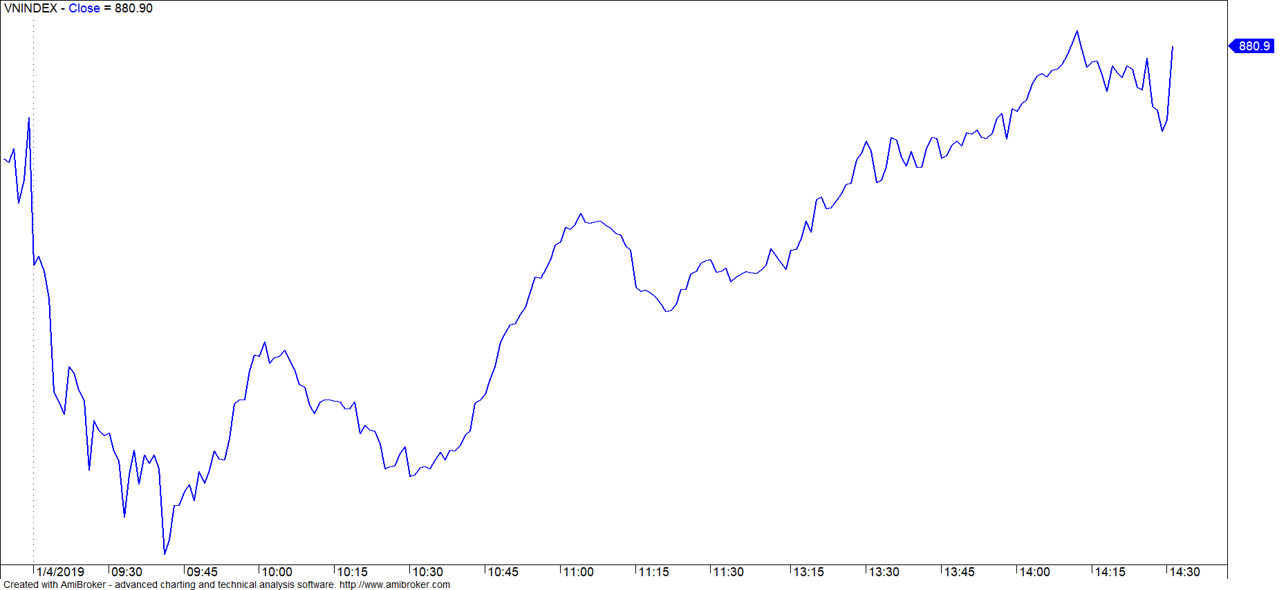

HNXINDEX

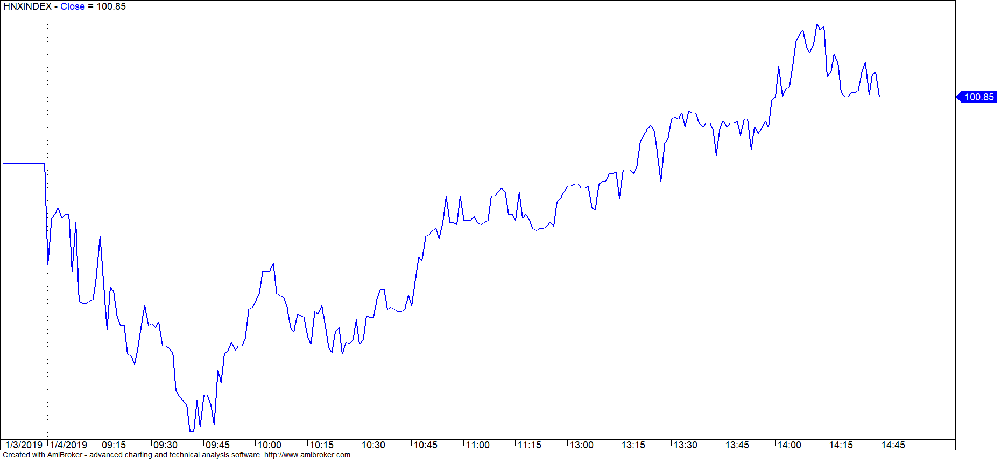

市場演變
週尾盤亞洲市場出現了積極變化，中國和香港市場上漲超過2％。其他市場都有小幅回升，包括越南市場。越南指數VN-index 收盤880.9點 +2.68 (+0.31%) ；HNX 100.85收盤 +0.32 (+0.32%)
越南股市早盤，ATO盤結束後指數一直處於紅跌，藍籌股如VIC，VHM，VRE，MWG，PNJ，VJC，PLX，GAS，BVH，HPG，或證券、房地產、建築、鋼鐵、油氣和水產等板塊均遭強勁拋售勢頭，股指在大多數股票都大幅下挫下無法獲得支撐。9時45分，Vn-Index跌失16.37點（1.86％）至861.85點; HNX指數下跌1,3％至99.2點。市場的強勁下跌引發了低接買盤進場，10點過後走勢在銀行和油氣板塊的引領下不斷升溫，市場流動性亦見擴增Vn-Index的跌幅在午休前已縮減至-5.33點（0.61％）報872.89點; Hnx-Index跌0.14％至100.38點。 交投在10點時方為熱絡，因此早盤的市場總流動性仍偏低，三大證交累計僅達1.75兆越盾。
午盤交投轉向積極， 許多藍籌股如VHM，MWG，PLX，VRE，FPT，HPG ......走漲，反彈動力也擴散到證券，銀行和油氣等板塊，幫助指數強勁復甦並轉綠漲作收。
外資在連續7盤買超後，今天已呈現賣超，集中賣超在 VJC值達680億盾 但 VNM ， E1VFVN30 基金 外資還是買超。

市場評論
我們認為市場可能會在下一交易日回升並會測試VN-INDEX在897點。同時市場可能在未來幾個交易日進入技術反彈階段，如果市場繼續回復上漲那短期的風險就降低了，投資人的心理也改觀。此外，股票暴露下降表明短期策略是繼續減少持有股票量可見市場將碰底但短期投資還是再等。
我們的趨勢指標2市場主要指數VN-INDEX是短期下跌趨勢支撐在907.35點趨勢 而HNX指數短期下跌趨勢支撐位為105.41點。因此，我們建議短期投資者暫時在外等待，限制在這價格範圍內賣出股票。
根據周線圖，我們評估VN-index 指數和VN30正在形成中期反轉模式，表明中期趨勢有更多積極跡象。 然而，兩個主要指數的中期趨勢仍為下跌。 因此，我們建議短期投資者暫時在外等待，限制在這價格範圍內賣出股票。
建議短期投資比重: 16%股票/84%現金。
建議中期投資比重: 24%股票/76%現金。
(股票趨勢追踪圖在下一頁內更新) 。

技術分析圖

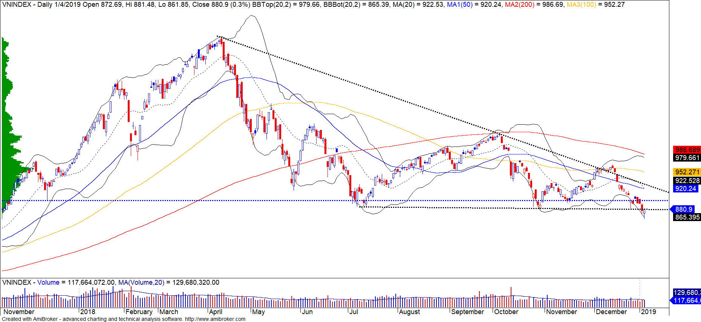
指數技術分析圖 VN-Index

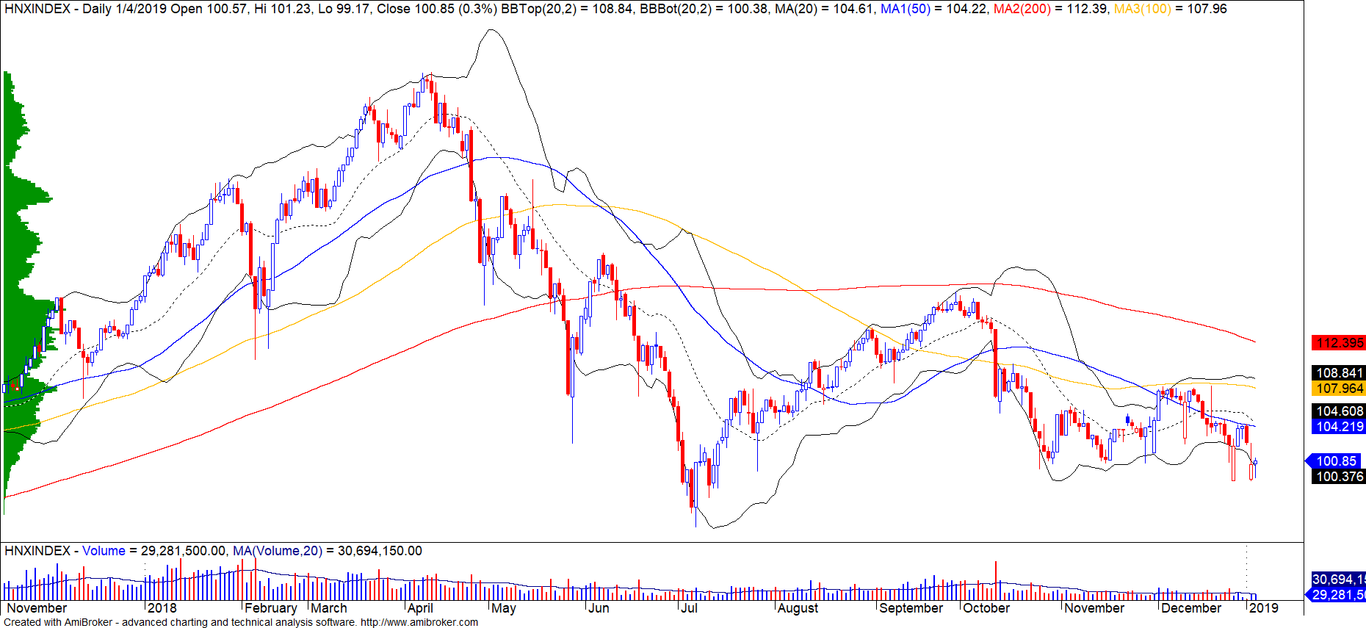
指數技術分析圖 HNX-Index

VN-Index指數 | 短期趨勢 | 中期趨勢 | 壓力 1 | 壓力 2 | 支撐 1 | 支撐 2
VN-Index指數 VN-Index | 下跌 | 下跌 | 972 | 1,025 | 897 | 780
VN-Index指數 HNX-Index | 下跌 | 下跌 | 110 | 117 | 100 | 96
VN-Index指數 VN30 | 下跌 | 下跌 | 946 | 995 | 865 | 768
VN-Index指數 VNMidcaps | 下跌 | 下跌 | 1,020 | 1,079 | 925 | 971
VN-Index指數 VNSmallcaps | 下跌 | 下跌 | 815 | 835 | 789 | 769
股票趨勢追蹤表

股票 | 價格 | 短期趨勢 | 中期趨勢 | 短期買價 | 短期停損 | 暫計短期利潤% | 短期訊號 | 中期買價 | 中期停損 | 暫計中期獲利% | 中期訊號
AAA | 14,250 | 下跌 | 下跌 |  | 15,390 |  |  |  | 16,612
ACB | 28,300 | 下跌 | 下跌 |  | 30,024 |  |  |  | 33,291
ACV | 85,400 | 上漲 | 上漲 | 81,800 | 85,174 | 4.40% |  | 90,000 | 74,376 | -5.11%
ANV | 24,500 | 下跌 | 下跌 |  | 28,506 |  |  | 21,450 | 25,326 | 18.07% | 賣出
ASM | 6,800 | 下跌 | 下跌 |  | 8,339 |  |  |  | 10,606
BFC | 25,000 | 下跌 | 下跌 |  | 26,521 |  |  |  | 26,729
BHN | 81,000 | 下跌 | 下跌 |  | 83,842 |  |  |  | 92,937
BID | 31,550 | 下跌 | 上漲 |  | 35,071 |  |  | 33,400 | 29,888 | -5.54%
BMP | 48,850 | 下跌 | 下跌 |  | 53,321 |  |  |  | 61,354
BSR | 13,200 | 下跌 | 下跌 |  | 14,437 |  |  |  | 16,998
BVH | 88,600 | 下跌 | 上漲 |  | 95,428 |  |  | 86,000 | 88,082 | 3.02%
BWE | 23,300 | 下跌 | 上漲 |  | 24,579 |  |  | 20,000 | 21,615 | 16.50%
CEO | 12,600 | 下跌 | 下跌 |  | 13,444 |  |  |  | 14,906
CHP | 21,000 | 下跌 | 下跌 |  | 21,433 |  |  |  | 22,586
CSM | 14,700 | 下跌 | 上漲 |  | 15,158 |  |  | 14,390 | 13,911 | 2.15%
CTD | 159,500 | 上漲 | 下跌 | 151,500 | 155,155 | 5.28% |  |  | 164,807
CTG | 18,350 | 下跌 | 下跌 |  | 20,167 |  |  |  | 23,926
CTI | 24,200 | 上漲 | 下跌 | 24,400 | 23,592 | -0.82% |  |  | 26,512
CVT | 18,200 | 下跌 | 下跌 |  | 19,850 |  |  |  | 24,062
DCM | 9,850 | 下跌 | 下跌 |  | 10,452 |  |  |  | 10,704
DGW | 22,000 | 下跌 | 下跌 |  | 23,438 |  |  |  | 25,903
DHA | 30,200 | 上漲 | 上漲 | 30,300 | 29,997 | -0.33% |  | 29,100 | 27,521 | 3.78%
DIG | 15,200 | 下跌 | 下跌 |  | 15,608 |  |  |  | 17,064
DHC | 29,650 | 下跌 | 下跌 |  | 32,039 |  |  | 35,785 | 29,901 | -16.44% | 賣出
DHG | 73,500 | 下跌 | 下跌 |  | 78,915 |  |  |  | 86,043
DGC | 43,400 | 下跌 | 下跌 |  | 46,400 |  |  |  | 52,201
DPG | 50,700 | 上漲 | 上漲 | 48,250 | 48,603 | 5.08% |  | 52,000 | 42,258 | -2.50%
DPM | 21,600 | 下跌 | 上漲 |  | 22,967 |  |  | 19,400 | 19,762 | 11.34%
DPR | 31,950 | 下跌 | 上漲 |  | 32,378 |  |  | 35,950 | 30,873 | -11.13%
DQC | 26,750 | 上漲 | 上漲 | 27,700 | 25,698 | -3.43% |  | 31,000 | 26,186 | -13.71%
DRC | 21,050 | 下跌 | 下跌 |  | 21,896 |  |  |  | 24,379
DXG | 22,700 | 下跌 | 下跌 |  | 24,465 |  |  |  | 27,692
ELC | 7,400 | 下跌 | 下跌 |  | 7,767 |  |  |  | 8,701
FCN | 14,150 | 下跌 | 下跌 |  | 15,222 |  |  | 16,309 | 14,479 | -11.22% | 賣出
FIT | 2,400 | 下跌 | 下跌 |  | 2,666 |  |  |  | 3,226
FMC | 29,100 | 下跌 | 上漲 |  | 30,129 |  |  | 24,700 | 26,427 | 17.81%
FPT | 41,100 | 下跌 | 下跌 |  | 42,572 |  |  |  | 45,959
GAS | 84,500 | 下跌 | 下跌 |  | 90,242 |  |  |  | 103,182
GEX | 20,750 | 下跌 | 下跌 |  | 22,975 |  |  |  | 26,074
GIL | 35,000 | 下跌 | 下跌 |  | 35,722 |  |  |  | 38,640
GMD | 25,550 | 下跌 | 下跌 |  | 27,411 |  |  | 27,300 | 25,612 | -6.18% | 賣出
GTN | 10,000 | 下跌 | 下跌 |  | 10,395 |  |  |  | 11,796
HAG | 4,660 | 下跌 | 下跌 |  | 4,958 |  |  |  | 5,867
HAX | 15,850 | 下跌 | 下跌 |  | 16,391 |  |  |  | 18,004
HBC | 15,500 | 下跌 | 下跌 |  | 17,722 |  |  |  | 21,918
HDB | 29,000 | 上漲 | 下跌 | 30,300 | 28,134 | -4.29% |  |  | 33,725
HNG | 15,400 | 下跌 | 上漲 |  | 16,156 |  |  | 8,200 | 14,502 | 87.80%
HPG | 29,700 | 下跌 | 下跌 |  | 31,743 |  |  |  | 35,016
HSG | 6,170 | 下跌 | 下跌 |  | 6,859 |  |  |  | 8,742
HT1 | 13,250 | 下跌 | 上漲 |  | 14,276 |  |  | 14,800 | 12,654 | -10.47%
HUT | 3,700 | 下跌 | 下跌 |  | 4,203 |  |  |  | 5,053
HVN | 34,800 | 上漲 | 下跌 | 35,700 | 32,922 | -2.52% |  |  | 37,369
ITD | 10,750 | 下跌 | 上漲 |  | 10,930 |  |  | 12,400 | 10,106 | -13.31%
KBC | 13,750 | 下跌 | 上漲 |  | 14,174 |  |  | 13,450 | 12,358 | 2.23%
KDH | 31,150 | 上漲 | 上漲 | 29,500 | 31,056 | 5.59% |  | 33,000 | 28,018 | -5.61%
KSB | 24,750 | 下跌 | 下跌 |  | 26,155 |  |  |  | 29,518
LCG | 7,980 | 下跌 | 下跌 |  | 8,196 |  |  |  | 8,886
LDG | 13,350 | 下跌 | 下跌 |  | 14,840 |  |  |  | 18,041
LIX | 48,000 | 下跌 | 上漲 |  | 50,124 |  |  | 44,400 | 45,486 | 8.11%
LPB | 8,800 | 下跌 | 下跌 |  | 9,230 |  |  |  | 10,145
LSS | 6,560 | 上漲 | 上漲 | 7,000 | 6,255 | -6.29% |  | 7,890 | 6,353 | -16.86%
MBB | 18,600 | 下跌 | 下跌 |  | 19,999 |  |  |  | 23,018
MPC | 37,900 | 下跌 | 下跌 |  | 42,240 |  |  |  | 48,712
MSN | 76,200 | 下跌 | 下跌 |  | 81,936 |  |  |  | 90,176
MSR | 18,100 | 下跌 | 上漲 |  | 19,137 |  |  | 19,884 | 17,887 | -8.97%
MWG | 83,600 | 下跌 | 下跌 |  | 87,875 |  |  |  | 92,518
NKG | 7,050 | 下跌 | 下跌 |  | 8,084 |  |  |  | 9,855
NLG | 25,500 | 下跌 | 下跌 |  | 26,533 |  |  |  | 29,453
NT2 | 25,900 | 上漲 | 上漲 | 25,400 | 24,161 | 1.97% |  | 25,900 | 25,656 | 0.00% | 買進
NTL | 18,000 | 下跌 | 上漲 | 10,000 | 18,387 | 83.87% | 賣出 | 10,450 | 15,873 | 72.25%
NTP | 40,200 | 下跌 | 下跌 |  | 42,077 |  |  |  | 48,317
PAC | 38,000 | 下跌 | 下跌 |  | 40,597 |  |  |  | 43,198
PC1 | 22,600 | 下跌 | 下跌 |  | 24,836 |  |  |  | 25,195
PDR | 25,250 | 下跌 | 下跌 |  | 26,202 |  |  |  | 28,383
PGC | 14,350 | 下跌 | 下跌 |  | 14,613 |  |  |  | 15,410
PHR | 34,650 | 上漲 | 上漲 | 29,300 | 31,292 | 18.26% |  | 24,000 | 27,860 | 44.38%
PNJ | 90,000 | 下跌 | 下跌 |  | 94,930 |  |  | 103,023 | 91,025 | -11.65% | 賣出
PLX | 54,900 | 下跌 | 下跌 |  | 57,280 |  |  |  | 63,605
POW | 15,500 | 上漲 | 下跌 | 14,300 | 14,596 | 8.39% |  |  | 16,115
PPC | 18,100 | 下跌 | 上漲 |  | 18,412 |  |  | 19,700 | 16,537 | -8.12%
PTB | 59,000 | 下跌 | 上漲 |  | 61,802 |  |  | 64,000 | 56,808 | -7.81%
PVS | 17,400 | 下跌 | 下跌 |  | 18,728 |  |  |  | 21,396
PVD | 14,300 | 下跌 | 下跌 |  | 15,500 |  |  |  | 18,518
PVI | 32,500 | 上漲 | 上漲 | 32,900 | 31,250 | -1.22% |  | 33,000 | 30,008 | -1.52%
PXS | 4,800 | 下跌 | 下跌 |  | 5,170 |  |  |  | 6,062
QNS | 41,800 | 下跌 | 上漲 |  | 42,966 |  |  | 41,500 | 3,058 | 0.72%
RAL | 81,400 | 下跌 | 下跌 |  | 87,002 |  |  |  | 95,117
REE | 29,800 | 下跌 | 下跌 |  | 31,470 |  |  |  | 34,432
SAB | 243,200 | 下跌 | 上漲 | 208,000 | 243,923 | 17.27% | 賣出 | 245,000 | 227,704 | -0.73%
SAM | 6,950 | 上漲 | 下跌 | 7,090 | 6,624 | -1.97% |  |  | 7,361
SBV | 13,800 | 下跌 | 下跌 |  | 15,136 |  |  |  | 18,559
SCR | 7,070 | 下跌 | 下跌 |  | 7,377 |  |  |  | 8,557
SHI | 6,320 | 下跌 | 上漲 | 6,680 | 6,342 | -5.07% | 賣出 | 6,990 | 5,879 | -9.59%
SJS | 17,400 | 下跌 | 上漲 |  | 18,852 |  |  | 18,100 | 15,245 | -3.87%
SKG | 17,000 | 下跌 | 下跌 | 17,450 | 17,225 | -1.29% | 賣出 |  | 19,471
SSI | 26,000 | 下跌 | 下跌 |  | 27,417 |  |  |  | 30,651
STB | 11,150 | 下跌 | 下跌 |  | 12,004 |  |  |  | 13,676
SVC | 42,800 | 下跌 | 下跌 |  | 44,087 |  |  |  | 47,423
TCB | 24,950 | 下跌 | 下跌 |  | 26,691 |  |  |  | N/A
TCM | 21,300 | 下跌 | 下跌 |  | 23,738 |  |  |  | 27,843
TDH | 10,000 | 下跌 | 下跌 |  | 10,336 |  |  |  | 11,745
TLH | 5,200 | 下跌 | 下跌 |  | 5,895 |  |  |  | 6,521
TMT | 8,970 | 下跌 | 上漲 |  | 9,524 |  |  | 9,290 | 8,746 | -3.44%
TNG | 16,000 | 下跌 | 上漲 |  | 17,490 |  |  | 12,000 | 15,302 | 33.33%
TYA | 10,700 | 上漲 | 下跌 | 10,900 | 10,340 | -1.83% |  |  | 11,557
VCB | 54,400 | 下跌 | 下跌 |  | 54,668 |  |  |  | 59,813
VCG | 21,900 | 下跌 | 上漲 | 20,300 | 22,275 | 9.73% | 賣出 | 19,200 | 19,040 | 14.06%
VFG | 39,000 | 上漲 | 上漲 | 39,300 | 36,083 | -0.76% |  | 34,394 | 34,815 | 13.39%
VGC | 17,900 | 上漲 | 下跌 | 16,300 | 17,391 | 9.82% |  |  | 18,454
VHC | 88,000 | 下跌 | 下跌 |  | 94,329 |  |  |  | 107,804
VHM | 74,000 | 下跌 | 上漲 |  | 76,059 |  |  | 80,000 | 68,839 | -7.50%
VIB | 17,600 | 下跌 | 下跌 |  | 18,546 |  |  |  | 20,594
VIC | 100,600 | 下跌 | 下跌 |  | 103,689 |  |  |  | 104,386
VIP | 6,750 | 下跌 | 下跌 |  | 7,033 |  |  |  | 7,294
VJC | 115,000 | 下跌 | 下跌 |  | 121,528 |  |  |  | 136,371
VNM | 125,000 | 下跌 | 下跌 |  | 128,080 |  |  |  | 137,337
VPB | 18,950 | 下跌 | 下跌 |  | 20,492 |  |  |  | 24,012
VPI | 41,350 | 下跌 | N/A |  | 42,912 |  |  |  | 6,177
VRC | 17,000 | 下跌 | 下跌 |  | 19,092 |  |  |  | 22,097
VRE | 27,500 | 下跌 | 下跌 |  | 30,083 |  |  |  | 33,377
VSC | 40,050 | 下跌 | 下跌 |  | 42,342 |  |  |  | 45,128
VSH | 16,600 | 下跌 | 下跌 |  | 17,649 |  |  | 17,400 | 16,642 | -4.36% | 賣出

胡志明市交易所 (HSX) |  |  |  | 河內交易所 (HSX) |  |  |  | UPCOM板 (UPCoM)
 | 收盤 | 漲跌% |  |  | 收盤 | 漲跌% |  |  | 收盤 | 漲跌%
VNI | 880.90 | 0.31% |  | HNI | 100.85 | 0.33% |  | UPCoM | 52.19 | 0.04%
VN30 | 840.17 | 0.16% |  | HN30 | 180.49 | 0.52%
VN Mid | 903.33 | 0.35% |  | VNX AllSh | 805.26 | 0.24%
VN Small | 754.02 | -0.15%
外資交易 | 成交值(十億盾) |  |  | 外資交易 | 成交值(十億盾) |  |  | 外資交易 | 成交值(十億盾)
買進 | 332.51 |  |  | 買進 | 13.71 |  |  | 買進 | 20.95
賣出 | 408.72 |  |  | 賣出 | 6.84 |  |  | 賣出 | 16.44
買賣超 | (76.21) |  |  | 買賣超 | 6.87 |  |  | 買賣超 | 4.51
下跌排名/股碼 | 漲跌(VND) | 漲跌% |  | 下跌排名/股碼 | 漲跌(VND) | 漲跌% |  | 下跌排名/股碼 | 漲跌(VND) | 漲跌%
HVG | 300 | 6.79% |  | PVS | 700 | 4.19% |  | IDC | 1600 | 7.96%
QCG | 210 | 5.26% |  | DGC | 900 | 2.12% |  | NTC | 1800 | 2.43%
KBC | 650 | 4.96% |  | VGC | 300 | 1.70% |  | SWC | 300 | 2.05%
HDG | 1550 | 4.71% |  | TNG | 200 | 1.27% |  | MCH | 1200 | 1.21%
PVT | 700 | 4.61% |  | TV2 | 1600 | 1.24% |  | VEA | 300 | 0.80%
上漲排名/股碼 | 漲跌(VND) | 漲跌% |  | 上漲排名/股碼 | 價格 trị thay đổi (VND | 漲跌% |  | 上漲排名/股碼 | 漲跌(VND) | 漲跌%
ASM | -510 | -6.98% |  | VCG | -900 | -3.95% |  | QTP | -800 | -8.79%
IDI | -470 | -6.97% |  | AMV | -700 | -1.86% |  | MPC | -800 | -2.07%
SJF | -520 | -6.94% |  | VC3 | -100 | -0.43% |  | ACV | -1200 | -1.39%
ANV | -1,000 | -3.92% |  |  |  |  |  | LPB | -100 | -1.12%
VCI | -1,500 | -3.38% |  |  |  |  |  | C4G | -100 | -1.01%
*備註：市值>5,000億盾；成交值>15億盾
市值排名/股碼 | 十億盾 |  |  | GTVH cao nhất | 十億盾 |  |  | 市值排名/股碼 | 十億盾
VIC | 306,396 |  |  | ACB | 39,909 |  |  | ACV | 175,855
VHM | 257,913 |  |  | VCS | 13,248 |  |  | MCH | 52,454
GAS | 229,483 |  |  | SHB | 9,986 |  |  | BSR | 52,305
VNM | 223,773 |  |  | PVS | 9,336 |  |  | HVN | 50,544
VCB | 215,506 |  |  | VCG | 8,083 |  |  | VGI | 49,415
交易量排名/股碼 | 成交值(百萬) | 漲跌% |  | 交易量排名/股碼 | 成交值(百萬) | 漲跌% |  | 交易量排名/股碼 | 成交值(百萬) | 漲跌%
HPG | 6.67 | 0.68% |  | NVB | 4.40 | 0.00% |  | PHH | 1.46
MBB | 6.50 | 0.54% |  | SHB | 3.82 | 0.00% |  | BSR | 1.31 | 0.00%
QCG | 5.36 | 5.26% |  | ART | 3.30 |  |  | LPB | 0.61 | -1.12%
KBC | 4.39 | 4.96% |  | PVS | 3.28 | 4.19% |  | BAB | 0.51 | -0.49%
CTG | 4.00 | 1.38% |  | ACB | 2.77 | 0.71% |  | HVN | 0.47 | -0.29%
資料源: BloomBerg & Yuanta Research |  |  |  | 資料源: BloomBerg & Yuanta Research |  |  |  | 資料源: BloomBerg & Yuanta Research
外資買賣統計

證劵  代碼 | 買超金額  (百萬盾) | 證劵  代碼 | 賣超金額  (百萬盾)
VNM | 24,763 | VJC | (68,311)
E1VFVN30 | 12,268 | HPG | (14,624)
KBC | 12,159 | CII | (10,615)
DPM | 7,700 | BID | (9,352)
VHM | 7,577 | VIC | (6,977)

HSX外資買/賣 超的前 5名

證劵  代碼 | 買超金額  (百萬盾) | 證劵  代碼 | 賣超金額  (百萬盾)
PVS | 7,367 | SHB | (1,144)
TNG | 973 | HUT | (538)
VCS | 609 | DBC | (410)
CEO | 356 | AMV | (385)
APS | 142 | SHS | (328)

HNX外資買/賣 超的前 5名

證劵  代碼 | 買超金額  (百萬盾) | 證劵  代碼 | 賣超金額  (百萬盾)
VTP | 2,469 | MCH | (2,510)
MPC | 1,897 | BSR | (1,633)
HVN | 1,616 | LPB | (1,078)
VEA | 1,329 | IN4 | (5)
OIL | 1,319 | TPS | (4)

UPCOM外資買/賣 超的前 5名

自營進出統計

股票代碼 | 買進金額 (百萬盾) | 股票代碼 | 賣出金額 (百萬盾)
VIC | 7,589 | SVI | 26,637
CII | 2,390 | E1VFVN30 | 13,910
FPT | 1,650 | VIC | 12,606
MSN | 1,499 | MSN | 11,077
PLX | 999 | VNM | 10,734

券商自營交易最大前名

越南證券市場投資人類別統計

6

資料源: FiinPro – YSVN

東南亞主要市場數據
 |  | Thái Lan | Indonesia | Philippines | Việt Nam
P/B |  | 2.0x | 2.2x | 1.9x | 2.8x
P/E |  | 16.5x | 19.5x | 18.3x | 17.1x
ROE | % | 12.11 | 11.70 | 10.72 | 15.08
ROA | % | 3.08 | 3.04 | 2.36 | 2.38
指數市值 | Bil.USD | 519.50 | 431.00 | 164 | 137.00
日成交 | Mil.USD | 1.40 | 0.28 | 0.05 | 0.15
股息殖利率 | % | 3.16 | 2.33 | 1.65 | 2.11
資料源: BloomBerg & YSVN, 2014

CÔNG TY CỔ PHẦN CHỨNG KHOÁN YUANTA VIỆT NAM

Phòng phân tích khối khách hàng cá nhân
Nguyễn Thế Minh
研究分析經理
+84 28 3622 6868 ext 3826 minh.nguyen@yuanta.com.vn
Quách Đức Khánh  高級分析專員  +84 28 3622 6868 ext 3833  khanh.quach@yuanta.com.vn |  | Nguyễn Trịnh Ngọc Hồng  分析專員  +84 28 3622 6868 ext 3832  hong.nguyen@yuanta.com.vn
Phòng Môi giới khách hàng cá nhân
Nguyễn Thanh Tùng  Giám đốc Môi giới Hội Sở  +84 28 3622 6868 ext 3609  tung.nguyen@yuanta.com.vn |  | Chung Kim Hoa  華人客戶部經理  +84 28 3622 6868 ext 3828  hoa.chung@yuanta.com.vn |  |  | Phù Vĩnh Quế  Giám đốc chi nhánh Chợ Lớn  +84 28 3622 6868  que.phu@yuanta.com.vn
Nguyễn Việt Quang  Giám đốc chi nhánh Hà Nội  +84 28 3622 6868 ext 3404  quang.nguyen@yuanta.com.vn |  | Võ Thị Thu Thủy  Giám đốc chi nhánh Bình Dương  +84 28 3622 6868 ext 3505  thuy.vo@yuanta.com.vn |  |  | Bùi Quốc Phong  Giám đốc chi nhánh Đồng Nai  +84 28 3622 6868  phong.bui@yuanta.com.vn
Nguyễn Đức Hoàn
Giám đốc trung tâm kinh doanh Nam Hà Nội
+84 28 3622 6868 ext 3409
hoan.nguyen@yuanta.com.vn

Appendix A: Important Disclosures
Analyst Certification
Each research analyst primarily responsible for the content of this research report, in whole or in part, certifies that with respect to each security or issuer that the analyst covered in this report: (1) all of the views expressed accurately reflect his or her personal views about those securities or issuers; and (2) no part of his or her compensation was, is, or will be, directly or indirectly, related to the specific recommendations or views expressed by that research analyst in the research report.

Ratings Definitions
BUY: We have a positive outlook on the stock based on our expected absolute or relative return over the investment period. Our thesis is based on our analysis of the company’s outlook, financial performance, catalysts, valuation and risk profile. We recommend investors add to their position.
HOLD-Outperform: In our view, the stock’s fundamentals are relatively more attractive than peers at the current price. Our thesis is based on our analysis of the company’s outlook, financial performance, catalysts, valuation and risk profile.
HOLD-Underperform: In our view, the stock’s fundamentals are relatively less attractive than peers at the current price. Our thesis is based on our analysis of the company’s outlook, financial performance, catalysts, valuation and risk profile.
SELL: We have a negative outlook on the stock based on our expected absolute or relative return over the investment period. Our thesis is based on our analysis of the company’s outlook, financial performance, catalysts, valuation and risk profile. We recommend investors reduce their position.
Under Review: We actively follow the company, although our estimates, rating and target price are under review.
Restricted: The rating and target price have been suspended temporarily to comply with applicable regulations and/or Yuanta policies.

Note: Yuanta research coverage with a Target Price is based on an investment period of 12 months. Greater China Discovery Series coverage does not have a formal 12 month Target Price and the recommendation is based on an investment period specified by the analyst in the report.

Global Disclaimer
© 2018 Yuanta. All rights reserved. The information in this report has been compiled from sources we believe to be reliable, but we do not hold ourselves responsible for its completeness or accuracy. It is not an offer to sell or solicitation of an offer to buy any securities. All opinions and estimates included in this report constitute our judgment as of this date and are subject to change without notice.

This report provides general information only. Neither the information nor any opinion expressed herein constitutes an offer or invitation to make an offer to buy or sell securities or other investments. This material is prepared for general circulation to clients and is not intended to provide tailored investment advice and does not take into account the individual financial situation and objectives of any specific person who may receive this report. Investors should seek financial advice regarding the appropriateness of investing in any securities, investments or investment strategies discussed or recommended in this report. The information contained in this report has been compiled from sources believed to be reliable but no representation or warranty, express or implied, is made as to its accuracy, completeness or correctness. This report is not (and should not be construed as) a solicitation to act as securities broker or dealer in any jurisdiction by any person or company that is not legally permitted to carry on such business in that jurisdiction.

Yuanta research is distributed in the United States only to Major U.S. Institutional Investors (as defined in Rule 15a-6 under the Securities Exchange Act of 1934, as amended and SEC staff interpretations thereof). All transactions by a US person in the securities mentioned in this report must be effected through a registered broker-dealer under Section 15 of the Securities Exchange Act of 1934, as amended. Yuanta research is distributed in Taiwan by Yuanta Securities Investment Consulting. Yuanta research is distributed in Hong Kong by Yuanta Securities (Hong Kong) Co. Limited, which is licensed in Hong Kong by the Securities and Futures Commission for regulated activities, including Type 4 regulated activity (advising on securities). In Hong Kong, this research report may not be redistributed, retransmitted or disclosed, in whole or in part or and any form or manner, without the express written

