2020/02/06
當日期貨市場：短期趨勢已轉為積極

合約走勢
 | 收盤 | +/- | 成交量 | 到期日
單位 | 點數 | 點數 | 合約 | 日期
VN30F2002 | 860.5 | 18.7 | 140,367 | 20/02
VN30F2003 | 860.0 | 16.5 | 391 | 19/03
VN30F2006 | 865.3 | 14.5 | 115 | 18/06
VN30F2009 | 867.6 | 19.5 | 31 | 17/09
源自：Bloomberg – YSVN

源自：Bloomberg – YSVN

源自：Bloomberg – YSVN

Pham Tan Phat
高級分析專員
Email: phat.pham@yuanta.com.vn
Phone: (084) 28 3622 6868 ext 3880

技術信號
- VN30F1M突破了累積階段，並在盤中上漲了近20點，再次反彈為上漲趨勢。但是合約成交量僅達14萬合約，在價格劇烈波動的情況下僅比前一盤略有增加。RSI指標顯示積極上漲，表明慣性的上漲將在下盤的開盤時繼續。
- MACD Histogram指標在30分鐘框架收窄和向下分散，因Daily MACD框架仍低於0，表明可能會形成修正階段。 VN30F1M的阻力位為866-870點，相當於Fibonacci Projection 100％。
投資策略
- 當天策略 (Intraday)：投資者已持有多頭，可考慮停利在865-866點，或停損於853點。
- 主要短期趨勢策略 (Daily)：投資者可考慮開多頭，並停損於840.93點。
趨勢 | VN30F2002-Daily | VN30F2002-1H
短期 | 上漲 | 上漲
支撐 1 | 810 | 858
支撐 2 | 750 | 850
阻力 1 | 870 | 866
阻力 2 | 910 | 870
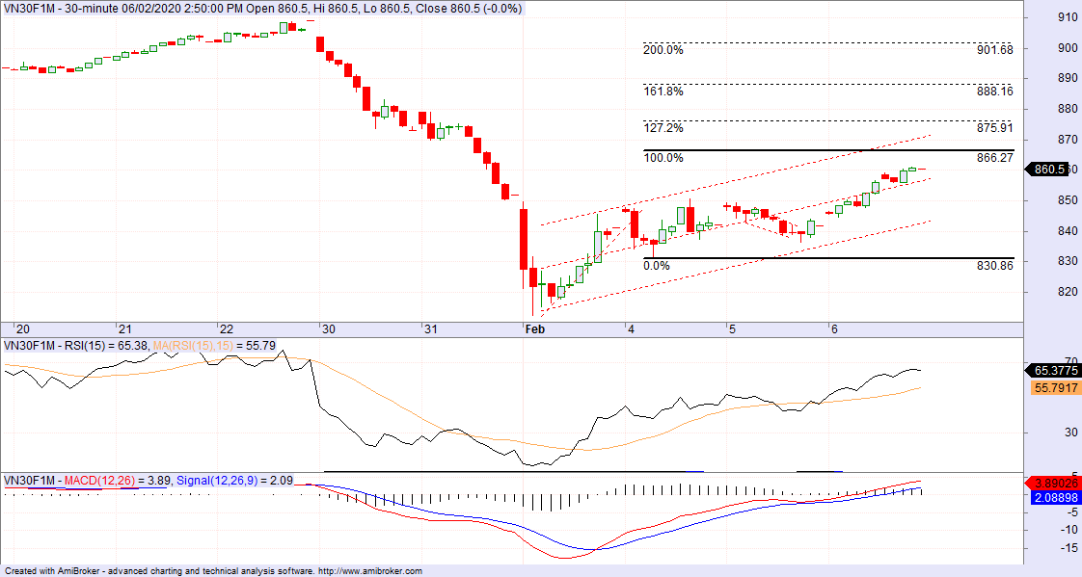

Error! Not a valid link.
每週
期貨合約
 | 收盤價 | +/- | +/- % | 成交量 | +/- % | Fair Value | 最後清算日 | 剩餘時間
 | 單位：點 | 點 | % | 合約 |  | 單位：點 |  | 日
VN30 Index | 862.9 | 17.6 | 2.1% | 0
VN30F2002 | 860.5 | 18.7 | 2.2% | 140,367 | 0.32% | 865 | 20/02/2020 | 14
VN30F2003 | 860.0 | 16.5 | 2.0% | 391 | 64.29% | 870 | 19/03/2020 | 41
VN30F2006 | 865.3 | 14.5 | 1.7% | 115 | 0.00% | 890 | 18/06/2020 | 132
VN30F2009 | 867.6 | 19.5 | 2.3% | 31 | -63.53% | 910 | 17/09/2020 | 223
每月
當日

上漲排名/  前5檔 | 影響  點數 | 下跌排名/  前5檔 | 影響  點數 |  |  | 股價上漲  前5檔 | % | 股價下跌  前5檔 | %
VPB | 3.14 | NVL | -0.45 |  |  | VRE | 6.91 | ROS | -6.25
TCB | 1.86 | SAB | -0.39 |  |  | STB | 6.83 | SAB | -2.06
STB | 1.72 | ROS | -0.16 |  |  | VPB | 5.59 | NVL | -1.85
HPG | 1.70 | BID | -0.07 |  |  | HDB | 5.28 | BID | -0.56
HDB | 1.38 | MSN | -0.06 |  |  | GAS | 5.27 | MSN | -0.20

VN30 指數股票名單
股票  代碼 | 企業名稱 | 產業 | 比重 | 收盤價 | 資本 | PER | PBR | 3個月  成交量 | 外資  持股 | 52 週  走高 | 52 週  走低
 |  | 單位 | % | VND | Tỷ VND | x | x | '000 cp | % | VND | VND
BID | 越南投資與發展商業股份銀行 | 金融 | 1.4% | 53,200 | 213,971 | 22.2 | 2.9 | 849 | 18% | 55,800 | 30,550
CTD | Coteccons建築股份公司 | 工業 | 0.3% | 53,100 | 4,051 | 6.0 | 0.5 | 101 | 47% | 146,200 | 47,750
CTG | 越南工商股份銀行 | 金融 | 1.5% | 27,750 | 103,324 | 10.9 | 1.3 | 4,507 | 30% | 28,100 | 19,500
BVH | Bao Viet (保越) 集團 | 金融 | 0.6% | 58,400 | 43,352 | 35.8 | 2.3 | 180 | 30% | 98,500 | 54,700
DPM | 油氣化學原料 – 化肥股份公司 | 原材料 | #VALUE! | 11,700 | 4,579 | 13.0 | 0.6 | 281 | 19% | 23,700 | 10,800
EIB | 越南進出口貿易股份銀行 | 金融 | 2.9% | 17,700 | 21,761 | 25.1 | 1.4 | 135 | 30% | 19,100 | 15,350
FPT | FPT發展投資工藝股份公司 | CNTT | 4.6% | 53,600 | 36,356 | 12.7 | 2.6 | 1,605 | 49% | 61,300 | 38,818
GAS | 越南氣體總公司 – 股份公司 | 公用服務 | 1.3% | 85,900 | 164,408 | 14.1 | 3.4 | 299 | 4% | 114,900 | 80,600
GMD | Gemadept運輸股份公司 | 工業 | #VALUE! | 19,500 | 5,790 | 12.2 | 0.9 | 298 | 49% | 29,150 | 17,800
HDB | 胡志明市發展商業股份銀行 | 金融 | 3.2% | 29,900 | 28,783 | 8.1 | 1.9 | 1,583 | 23% | 32,350 | 24,450
HPG | Hoa Phat (和發) 集團股份公司 | 原材料 | 6.6% | 25,200 | 69,579 | 9.8 | 1.5 | 6,350 | 39% | 27,385 | 20,300
MBB | 軍隊貿易股份銀行 | 金融 | 4.8% | 21,800 | 50,700 | 6.3 | 1.3 | 4,569 | 21% | 23,900 | 18,611
MSN | Masan集團股份公司 | 必需消費品 | 3.7% | 49,900 | 58,330 | 10.5 | 1.4 | 966 | 39% | 92,000 | 46,600
MWG | 世界移動通信投資股份公司 | 非必需消費品 | 5.1% | 109,500 | 49,626 | 12.7 | 4.0 | 668 | 49% | 129,500 | 80,600
NVL | Nova 房地產投資集團股份公司 | 房地產 | 2.8% | 53,000 | 51,386 | 14.9 | 2.4 | 352 | 7% | 65,100 | 52,800
PNJ | Phu Nhuan (富潤) 珠寶股份公司 | 非必需消費品 | 2.4% | 83,900 | 18,893 | 15.7 | 4.1 | 585 | 49% | 92,500 | 71,000
REE | 冷機電股份公司 | 工業 | 0.9% | 34,000 | 10,542 | 6.4 | 1.0 | 709 | 49% | 40,150 | 30,750
ROS | FLC Faros 建築股份公司 | 工業 | 0.3% | 7,050 | 4,002 | 22.5 | 0.7 | 21,750 | 4% | 35,750 | 7,000
SAB | Sai Gon (西貢) 飲料-酒-啤酒股份公司 | 必需消費品 | 2.1% | 190,000 | 121,843 | 25.4 | 6.5 | 34 | 63% | 291,000 | 189,300
SBT | Bien Hoa – Thanh Thanh Cong (邊和 – 成成功) 股份公司 | 必需消費品 | 0.8% | 18,000 | 10,561 | 35.5 | 1.5 | 1,219 | 6% | 21,500 | 15,400
SSI | SSI 西貢證券股份公司 | 金融 | 0.9% | 17,700 | 9,170 | 10.4 | 0.9 | 1,493 | 55% | 29,600 | 16,500
STB | 西貢商信銀行 (sacombank) | 金融 | 3.1% | 10,950 | 19,750 | 8.0 | 0.7 | 3,285 | 12% | 13,200 | 9,750
TCB | 越南技商股份銀行 (Techcombank) | 金融 | 8.0% | 22,350 | 78,228 | 7.8 | 1.3 | 1,835 | 22% | 28,200 | 19,900
VCB | 越南外商貿易股份銀行 | 金融 | 4.2% | 89,400 | 331,574 | 17.9 | 3.9 | 768 | 24% | 95,000 | 56,800
VHM | Vinhomes 股份公司 | 房地產 | 5.1% | 86,800 | 285,530 | 13.6 | 5.2 | 1,381 | 15% | 102,300 | 76,300
VIC | Vingroup集團股份公司 | 房地產 | 8.3% | 114,400 | 386,950 | 50.4 | 5.1 | 423 | 15% | 126,500 | 101,200
VJC | Vietjet越捷航空股份公司 | 工業 | 5.3% | 127,500 | 66,789 | 16.2 | 4.4 | 443 | 19% | 148,800 | 107,300
VNM | 越南牛奶股份公司 | 必需消費品 | 9.4% | 107,500 | 187,198 | 19.6 | 6.8 | 968 | 59% | 152,600 | 101,000
VPB | Viet Nam Thinh Vuong  (越南繁榮) 貿易股份銀行 | 金融 | 6.9% | 25,500 | 62,163 | 7.6 | 1.5 | 2,012 | 23% | 25,500 | 17,500
VRE | Vincom Retail 股份公司 | 房地產 | 2.0% | 30,950 | 70,328 | 24.7 | 2.6 | 2,906 | 33% | 39,950 | 27,950

元大證劵（越南）公司

個人客戶分析部
Nguyễn Thế Minh
研究分析經理
+84 28 3622 6868 ext 3826
minh.nguyen@yuanta.com.vn
Quách Đức Khánh  高級分析專員  +84 28 3622 6868 ext 3833  khanh.quach@yuanta.com.vn | Phạm Tấn Phát  高級分析專員  +84 28 3622 6868 ext 3880  phat.pham@yuanta.com.vn
Nguyễn Trịnh Ngọc Hồng
分析專員
+84 28 3622 6868 ext 3832
hong.nguyen@yuanta.com.vn

個人客戶業務部
Nguyễn Thanh Tùng  總公司業務經理  +84 28 3622 6868 ext 3609  tung.nguyen@yuanta.com.vn |  | Chung Kim Hoa  華人客戶部經理  +84 28 3622 6868 ext 3828  hoa.chung@yuanta.com.vn | Phù Vĩnh Quế  堤岸分行經理  +84 28 3622 6868  que.phu@yuanta.com.vn
Nguyễn Việt Quang  河內分行經理  +84 28 3622 6868 ext 3404  quang.nguyen@yuanta.com.vn |  | Võ Thị Thu Thủy  平陽分行經理  +84 28 3622 6868 ext 3505  thuy.vo@yuanta.com.vn | Bùi Quốc Phong  同奈分行經理  +84 28 3622 6868  phong.bui@yuanta.com.vn
Nguyễn Đức Hoàn  河內南部營業中心經理  +84 28 3622 6868 ext 3409  hoan.nguyen@yuanta.com.vn | Võ Đình Tuấn  峴港分行經理  +84 28 3622 6868 ext 3301  tuan.vo@yuanta.com.vn

Appendix A: Important Disclosures
Analyst Certification
Each research analyst primarily responsible for the content of this research report, in whole or in part, certifies that with respect to each security or issuer that the analyst covered in this report: (1) all of the views expressed accurately reflect his or her personal views about those securities or issuers; and (2) no part of his or her compensation was, is, or will be, directly or indirectly, related to the specific recommendations or views expressed by that research analyst in the research report.

Ratings Definitions
BUY: We have a positive outlook on the stock based on our expected absolute or relative return over the investment period. Our thesis is based on our analysis of the company’s outlook, financial performance, catalysts, valuation and risk profile. We recommend investors add to their position.
HOLD-Outperform: In our view, the stock’s fundamentals are relatively more attractive than peers at the current price. Our thesis is based on our analysis of the company’s outlook, financial performance, catalysts, valuation and risk profile.
HOLD-Underperform: In our view, the stock’s fundamentals are relatively less attractive than peers at the current price. Our thesis is based on our analysis of the company’s outlook, financial performance, catalysts, valuation and risk profile.
SELL: We have a negative outlook on the stock based on our expected absolute or relative return over the investment period. Our thesis is based on our analysis of the company’s outlook, financial performance, catalysts, valuation and risk profile. We recommend investors reduce their position.
Under Review: We actively follow the company, although our estimates, rating and target price are under review.
Restricted: The rating and target price have been suspended temporarily to comply with applicable regulations and/or Yuanta policies.

Note: Yuanta research coverage with a Target Price is based on an investment period of 12 months. Greater China Discovery Series coverage does not have a formal 12 month Target Price and the recommendation is based on an investment period specified by the analyst in the report.

Global Disclaimer
© 2018 Yuanta. All rights reserved. The information in this report has been compiled from sources we believe to be reliable, but we do not hold ourselves responsible for its completeness or accuracy. It is not an offer to sell or solicitation of an offer to buy any securities. All opinions and estimates included in this report constitute our judgment as of this date and are subject to change without notice.

This report provides general information only. Neither the information nor any opinion expressed herein constitutes an offer or invitation to make an offer to buy or sell securities or other investments. This material is prepared for general circulation to clients and is not intended to provide tailored investment advice and does not take into account the individual financial situation and objectives of any specific person who may receive this report. Investors should seek financial advice regarding the appropriateness of investing in any securities, investments or investment strategies discussed or recommended in this report. The information contained in this report has been compiled from sources believed to be reliable but no representation or warranty, express or implied, is made as to its accuracy, completeness or correctness. This report is not (and should not be construed as) a solicitation to act as securities broker or dealer in any jurisdiction by any person or company that is not legally permitted to carry on such business in that jurisdiction.

Yuanta research is distributed in the United States only to Major U.S. Institutional Investors (as defined in Rule 15a-6 under the Securities Exchange Act of 1934, as amended and SEC staff interpretations thereof). All transactions by a US person in the securities mentioned in this report must be effected through a registered broker-dealer under Section 15 of the Securities Exchange Act of 1934, as amended. Yuanta research is distributed in Taiwan by Yuanta Securities Investment Consulting. Yuanta research is distributed in Hong Kong by Yuanta Securities (Hong Kong) Co. Limited, which is licensed in Hong Kong by the Securities and Futures Commission for regulated activities, including Type 4 regulated activity (advising on securities). In Hong Kong, this research report may not be redistributed, retransmitted or disclosed, in whole or in part or and any form or manner, without the express written

