|  |  |  |  |  |
| --- | --- | --- | --- | --- |
| **Strategy Weekly: Momentum continues to point north**  **June 11, 2021** | | | | |
| **Matthew Smith, CFA**  **Head of Research**  +84 28 3622 6868  [matthew.smith@yuanta.com.vn](mailto:matthew.smith@yuanta.com.vn) | **A modest correction.** The VNI finally posted a correctionlast week, but Friday’s rally ensured that the index closed at just -1.6% lower week-on-week. The market remains remarkably resilient in light of the ongoing (and worsening, in HCMC at least) pandemic outbreak. Turnover remains strong, and capital increases by the brokers should ensure continued margin finance availability going forward. | | |
|  | | **Index, Flows, and FX Performance**   * **VNINDEX**: 1352 (-1.6% WoW / +22.5% YTD / +55.8% YoY) * **VHINDEX**: 317 (-4.0% WoW / +55.9% YTD / +172.9% YoY) * **UPCOM Index**: 88.9 (-1.8% WoW / +19.4% YTD / +59.0% YoY) * **Average daily turnover:** US$1,431 mn (-1.5% WoW) * **Foreigners net sold** US$32 mn of three-index constituents * **VND:USD rate: 22,973** (28bps WoW / +54bp YTD / +98bp YoY) |  | | |

|  |  |  |  |  |  |  |  |  |  |  |  |  |  |  |  |  |  |  |  |  |  |  |  |  |  |  |  |  |  |  |  |  |  |  |  |  |  |  |  |  |  |  |  |  |  |  |  |  |  |  |  |  |  |  |  |  |  |  |  |  |  |  |  |  |  |  |  |  |  |  |  |  |  |  |  |  |  |  |  |  |  |  |  |  |  |  |  |  |  |  |  |  |  |  |  |  |  |  |  |  |  |  |  |  |  |  |  |  |  |  |  |  |  |  |  |  |  |  |  |  |  |  |  |  |  |  |  |  |  |  |  |  |  |  |  |  |  |  |  |  |  |  |  |  |  |  |  |  |  |  |  |  |  |  |  |  |  |  |  |  |  |  |  |  |  |  |
| --- | --- | --- | --- | --- | --- | --- | --- | --- | --- | --- | --- | --- | --- | --- | --- | --- | --- | --- | --- | --- | --- | --- | --- | --- | --- | --- | --- | --- | --- | --- | --- | --- | --- | --- | --- | --- | --- | --- | --- | --- | --- | --- | --- | --- | --- | --- | --- | --- | --- | --- | --- | --- | --- | --- | --- | --- | --- | --- | --- | --- | --- | --- | --- | --- | --- | --- | --- | --- | --- | --- | --- | --- | --- | --- | --- | --- | --- | --- | --- | --- | --- | --- | --- | --- | --- | --- | --- | --- | --- | --- | --- | --- | --- | --- | --- | --- | --- | --- | --- | --- | --- | --- | --- | --- | --- | --- | --- | --- | --- | --- | --- | --- | --- | --- | --- | --- | --- | --- | --- | --- | --- | --- | --- | --- | --- | --- | --- | --- | --- | --- | --- | --- | --- | --- | --- | --- | --- | --- | --- | --- | --- | --- | --- | --- | --- | --- | --- | --- | --- | --- | --- | --- | --- | --- | --- | --- | --- | --- | --- | --- | --- | --- | --- | --- | --- | --- |
| |  |  |  |  |  | | --- | --- | --- | --- | --- | | **VN30 Components** | | |  |  | | **Ticker** | **Closing price (VND K)** | **WoW chg** | **Cont to VN30 (WoW)** | **TTM PE (x)** | | BID | 45.2 | -7.8% | -4% | 22 | | BVH | 57.3 | 0.4% | 0% | 22 | | CTG | 52.9 | -2.0% | -6% | 11 | | FPT | 83.5 | -1.4% | -6% | 20 | | GAS | 87.0 | -4.8% | -3% | 22 | | HDB | 34.5 | -2.8% | -8% | 11 | | HPG | 53.1 | -2.6% | -23% | 13 | | KDH | 36.8 | 3.4% | 3% | 19 | | MBB | 39.4 | -5.2% | -24% | 11 | | MSN | 106.0 | -1.2% | -4% | 82 | | MWG | 137.0 | -0.4% | -1% | 15 | | NVL | 104.9 | 1.8% | 7% | 34 | | PDR | 87.4 | 6.8% | 8% | 32 | | PLX | 54.0 | -5.6% | -3% | 18 | | PNJ | 96.9 | -3.7% | -5% | 20 | | POW | 12.1 | -8.0% | -3% | 12 | | REE | 54.9 | -4.4% | -2% | 10 | | SBT | 21.3 | 1.9% | 1% | 19 | | SSI | 50.1 | 2.8% | 4% | 17 | | STB | 30.5 | -5.1% | -19% | 20 | | TCB | 52.6 | -3.7% | 31% | 13 | | TCH | 21.9 | -0.9% | -0% | 9 | | TPB | 36.6 | -6.2% | -10% | 10 | | VCB | 102.8 | -2.0% | -6% | 18 | | VHM | 106.0 | 1.4% | 5% | 13 | | VIC | 118.0 | -2.5% | -12% | 54 | | VJC | 115.5 | 7.5% | 16% | 51 | | VNM | 92.0 | 4.1% | 27% | 20 | | VPB | 71.7 | 0.0% | 0% | 15 | | VRE | 31.5 | -2.2% | -3% | 27 | | Source: Bloomberg, Yuanta Vietnam. Pricing date: Jun 11, 2021. | | | | | | Banks and basic materials took a breather last week after driving the index northward since April. Not surprisingly, weekly breadth was negative, with the VNI posting 160 gainers vs. 207 losers and the VN30 large caps (which have provided much of the broader market’s YTD upside) posting 9 gainers vs. 20 losers. In keeping with the spirit of the times, airline VJC (+7.5%) outperformed the other big caps amid mixed, but largely negative, newsflow on the ongoing COVID-19 outbreak.  The [extension](https://yuanta.com.vn/wp-content/uploads/2021/06/Impact-of-Document-3947-NHNN.pdf) of regulator-mandated forbearance on borrowers who have been impacted by COVID-19 came as no surprise. The extension of this policy is highly sensible given the exogenous shock presented by COVID-19. But analyst Tanh Tran argues that the implied deterioration in bank asset quality compels investors to focus on [high-quality banks](https://yuanta.com.vn/wp-content/uploads/2021/05/Banks_CAMEL_1Q21_Updated.pdf). Specifically, we those with high LLR ratios, as such banks are better prepared for the eventual recognition of increased NPLs. [VCB](https://yuanta.com.vn/wp-content/uploads/2021/01/VCB_Company-Update_Jan_2021.pdf) is our top pick.    *Source: FiinPro, SBV, Yuanta Vietnam*  Stick to quality. Tanh’s mantra on the banks is applicable across the universe of Vietnamese stocks. Our top picks remain VHM, KDH, VCB, and DHC. |



**August 17, 2020**

*Source: Bloomberg (Jun 11)*

*Source: FiinPro, Bloomberg, Yuanta Vietnam (June 11)*

**Breadth has been trending down gradually, with most stocks trading below their 50-day moving averages**

|  |  |  |  |  |  |  |  |  |  |  |  |  |  |  |  |  |  |  |  |  |  |  |  |  |  |  |  |  |  |  |  |  |  |  |  |  |  |  |  |  |  |  |  |  |  |  |  |  |  |  |  |  |  |  |  |  |  |  |  |  |  |  |  |  |  |  |  |  |  |  |  |  |  |  |  |  |  |
| --- | --- | --- | --- | --- | --- | --- | --- | --- | --- | --- | --- | --- | --- | --- | --- | --- | --- | --- | --- | --- | --- | --- | --- | --- | --- | --- | --- | --- | --- | --- | --- | --- | --- | --- | --- | --- | --- | --- | --- | --- | --- | --- | --- | --- | --- | --- | --- | --- | --- | --- | --- | --- | --- | --- | --- | --- | --- | --- | --- | --- | --- | --- | --- | --- | --- | --- | --- | --- | --- | --- | --- | --- | --- | --- | --- | --- | --- |
|  |  | |  |  |  |  |  |  |  | | --- | --- | --- | --- | --- | --- | --- | | **VN 30 breadth** | | | | |  | | |  | **WoW** | | **MoM** | | **YTD** | | | Gainers | 9 | | 24 | | 24 | | | Losers | 20 | | 5 | | 6 | | | Source: Bloomberg (Jun 11) | | | | |  | | | **VNI breadth** | | | |  | |  | | |  | | **WoW** | | **MoM** | | **YTD** | | | Gainers | | 160 | | 244 | | 267 | | | Losers | | 207 | | 133 | | 106 | | | Source: Bloomberg (Jun 11) | | | | | |  | | |

*Source: Bloomberg, Yuanta Vietnam (Jun 11) Source: Bloomberg, Yuanta Vietnam*

*Source: Bloomberg, Yuanta Vietnam*

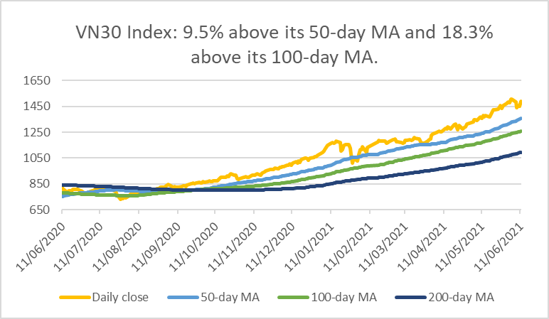 *Source: Bloomberg, Yuanta Vietnam*

*Source: Bloomberg, Yuanta Vietnam*

*Source: FiinPro, Yuanta Vietnam (Jun 11)*

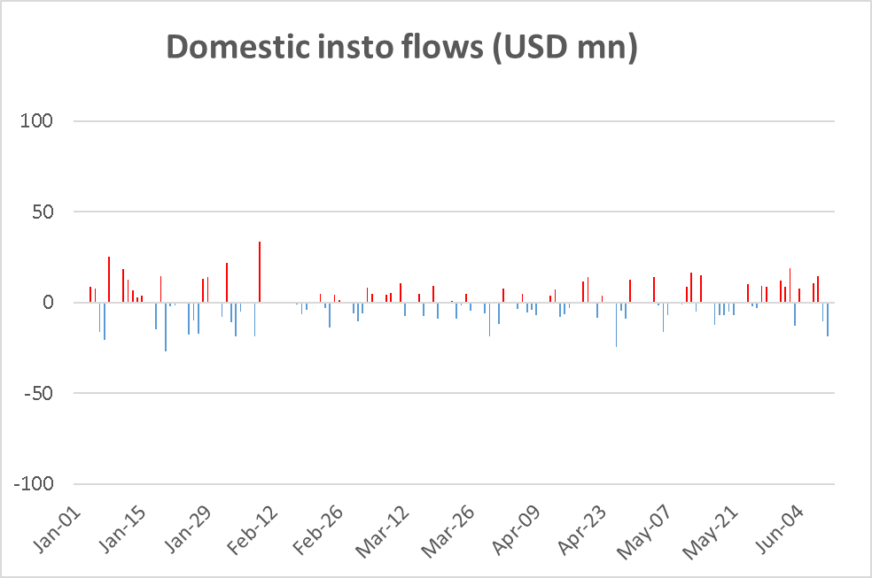

*Source: FiinPro, Yuanta Vietnam (data updated to Jun 11)*

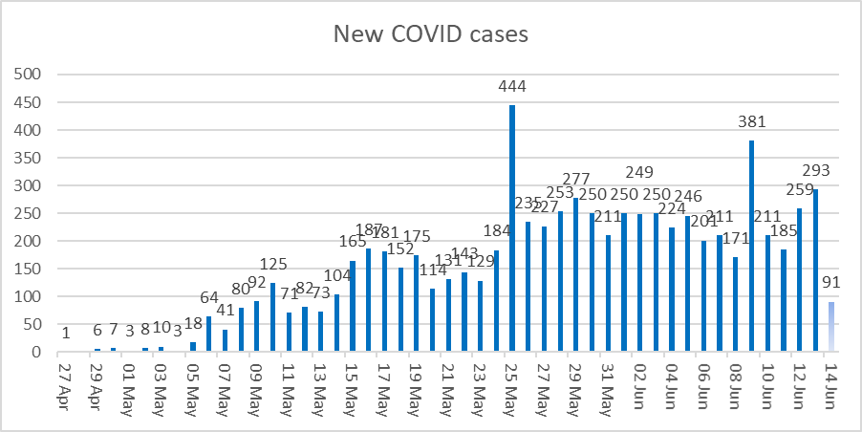

*Source: Vnexpress (Note: June 14 datapoint reflects the total new cases as of noon).*

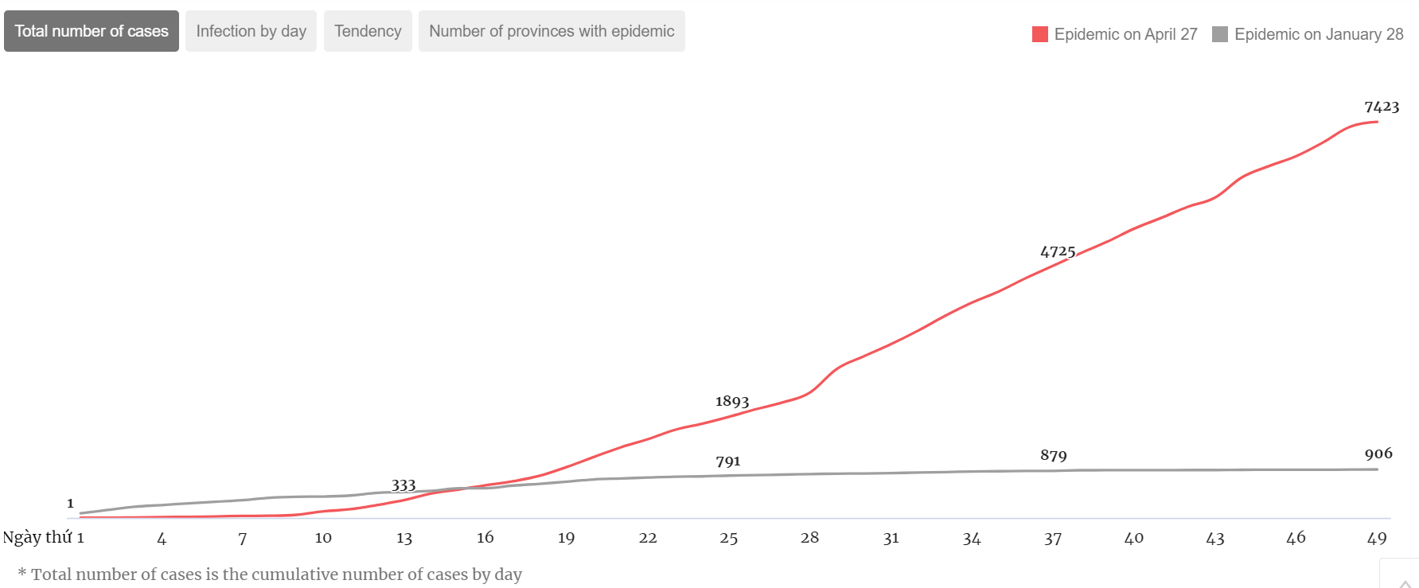

*Source: Vnexpress*

|  |  |  |
| --- | --- | --- |
| **The VNI’s trailing PE ratio as of Friday’s close was 18.5x.** |  | **The mainboard’s forward (2021E) PE is now 16.4x, based on Bloomberg consensus.** |
|  |  |  |
| *Source: Bloomberg, Yuanta Vietnam* |  | *Source: Bloomberg (2021E consensus PE), Yuanta Vietnam* |

|  |  |  |
| --- | --- | --- |
| **Vietnam stocks are cheap vs. the region on a trailing P/E basis…** |  | **…but in the middle of the pack on forward earnings multiples.** |
|  |  |  |
| *Source: Bloomberg, Yuanta Vietnam (Jun 11)* |  | *Source: Bloomberg (2021E consensus PE), Yuanta Vietnam (Jun 11)* |

**Vietnam stocks posted a rare week of underperformance vs the region last week.**

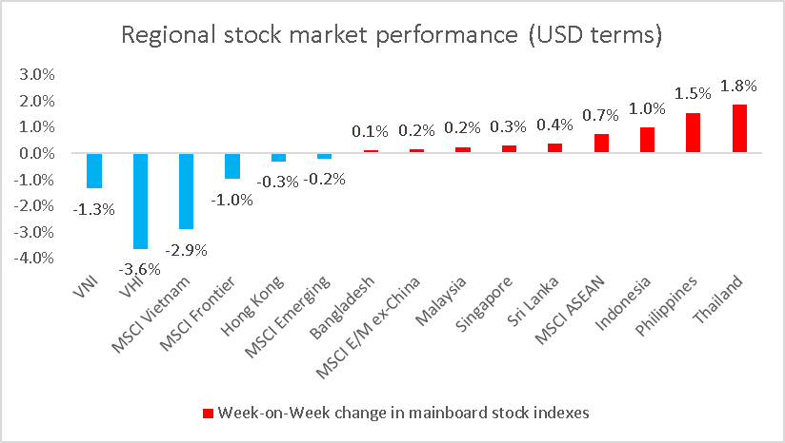

*Source: Bloomberg, Yuanta Vietnam (Jun 11)*

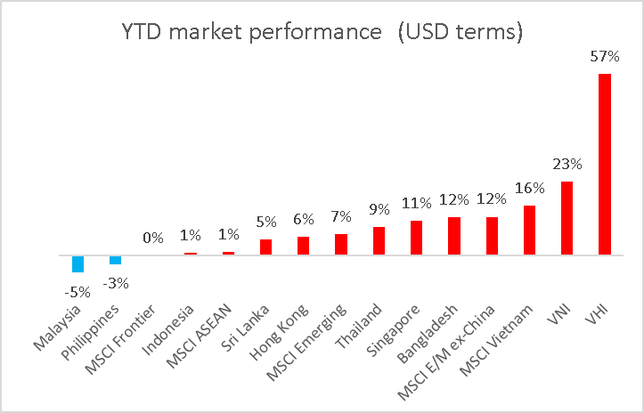

*Source: Bloomberg, Yuanta Vietnam (Jun 11)*

**Regional currencies: VND strengthened sharply against the USD, along with regional peer currencies**

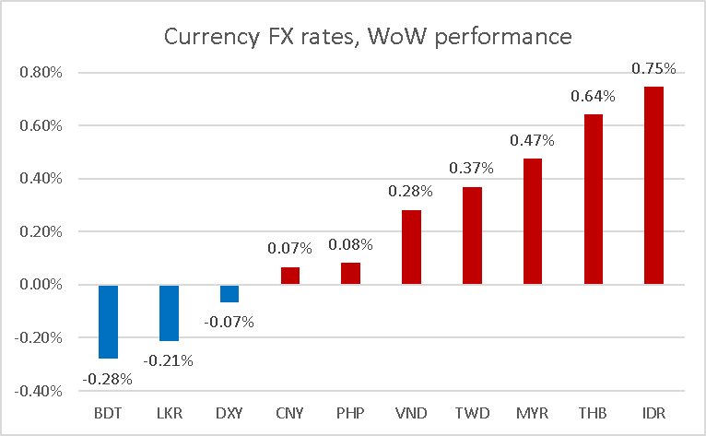

*Source: Bloomberg (Jun 11)*

|  |  |  |
| --- | --- | --- |
| **Grey market US dollar cash premium bounced a few basis points last week…** |  | **…but only because of an unusually sharp increase in the official VND cross rate.** |
|  |  |  |
| Source: FiinPro, Yuanta Vietnam. Bank data refers to VCB’s published electronic selling price vs. the “free market” price for USD notes. |  | Source: FiinPro, Yuanta Vietnam |
| **Global precious metals prices have been on a roll in recent weeks after the worst 1Q in years.** |  | **Even the SJC’s official gold price has started to move higher, albeit far more gradually.** |
|  |  |  |
| Source: FiinPro, Yuanta Vietnam. Bank data refers to VCB’s published electronic selling price vs. the “free market” price for USD notes. |  | Source: FiinPro, Yuanta Vietnam |

***Sector performance YTD -- Banks & materials have been the market leaders, but both sectors saw profit-taking amid last week’s burst of volatility.***

*Source: Bloomberg* *(Jun 11)*



Appendix A: Important Disclosures

**Analyst Certification**

Each research analyst primarily responsible for the content of this research report, in whole or in part, certifies that with respect to each security or issuer that the analyst covered in this report: (1) all of the views expressed accurately reflect his or her personal views about those securities or issuers; and (2) no part of his or her compensation was, is, or will be, directly or indirectly, related to the specific recommendations or views expressed by that research analyst in the research report.

**Ratings Definitions**

BUY: We have a positive outlook on the stock based on our expected absolute or relative return over the investment period. Our thesis is based on our analysis of the company’s outlook, financial performance, catalysts, valuation and risk profile. We recommend investors add to their position.

HOLD-Outperform: In our view, the stock’s fundamentals are relatively more attractive than peers at the current price. Our thesis is based on our analysis of the company’s outlook, financial performance, catalysts, valuation and risk profile.

HOLD-Underperform: In our view, the stock’s fundamentals are relatively less attractive than peers at the current price.  Our thesis is based on our analysis of the company’s outlook, financial performance, catalysts, valuation and risk profile.

SELL: We have a negative outlook on the stock based on our expected absolute or relative return over the investment period. Our thesis is based on our analysis of the company’s outlook, financial performance, catalysts, valuation and risk profile. We recommend investors reduce their position.

Under Review: We actively follow the company, although our estimates, rating and target price are under review.

Restricted: The rating and target price have been suspended temporarily to comply with applicable regulations and/or Yuanta policies.

Note: Yuanta research coverage with a Target Price is based on an investment period of 12 months. Greater China Discovery Series coverage does not have a formal 12 month Target Price and the recommendation is based on an investment period specified by the analyst in the report.

**Global Disclaimer**

© 2019 Yuanta. All rights reserved. The information in this report has been compiled from sources we believe to be reliable, but we do not hold ourselves responsible for its completeness or accuracy. It is not an offer to sell or solicitation of an offer to buy any securities. All opinions and estimates included in this report constitute our judgment as of this date and are subject to change without notice.

This report provides general information only. Neither the information nor any opinion expressed herein constitutes an offer or invitation to make an offer to buy or sell securities or other investments. This material is prepared for general circulation to clients and is not intended to provide tailored investment advice and does not take into account the individual financial situation and objectives of any specific person who may receive this report. Investors should seek financial advice regarding the appropriateness of investing in any securities, investments or investment strategies discussed or recommended in this report. The information contained in this report has been compiled from sources believed to be reliable but no representation or warranty, express or implied, is made as to its accuracy, completeness or correctness. This report is not (and should not be construed as) a solicitation to act as securities broker or dealer in any jurisdiction by any person or company that is not legally permitted to carry on such business in that jurisdiction.

Yuanta research is distributed in the United States only to Major U.S. Institutional Investors (as defined in Rule 15a-6 under the Securities Exchange Act of 1934, as amended and SEC staff interpretations thereof). All transactions by a US person in the securities mentioned in this report must be effected through a registered broker-dealer under Section 15 of the Securities Exchange Act of 1934, as amended. Yuanta research is distributed in Taiwan by Yuanta Securities Investment Consulting. Yuanta research is distributed in Hong Kong by Yuanta Securities (Hong Kong) Co. Limited, which is licensed in Hong Kong by the Securities and Futures Commission for regulated activities, including Type 4 regulated activity (advising on securities). In Hong Kong, this research report may not be redistributed, retransmitted or disclosed, in whole or in part or and any form or manner, without the express written consent of Yuanta Securities (Hong Kong) Co. Limited.

Taiwan persons wishing to obtain further information on any of the securities mentioned in this publication should contact:

Attn: Research

Yuanta Securities Investment Consulting

4F, 225,

Section 3 Nanking East Road, Taipei 104

Taiwan

Hong Kong persons wishing to obtain further information on any of the securities mentioned in this publication should contact:

Attn: Research

Yuanta Securities (Hong Kong) Co. Ltd

23/F, Tower 1, Admiralty Centre

18 Harcourt Road,

Hong Kong

Korean persons wishing to obtain further information on any of the securities mentioned in this publication should contact:

Head Office

Yuanta Securities Building

Euljiro 76 Jung-gu

Seoul, Korea 100-845

Tel: +822 3770 3454

Indonesia persons wishing to obtain further information on any of the securities mentioned in this publication should contact:

Attn: Research

PT YUANTA SECURITIES INDONESIA

(A member of the Yuanta Group)

Equity Tower, 10th Floor Unit EFGH

SCBD Lot 9

Jl. Jend. Sudirman Kav. 52-53

Tel: (6221) – 5153608 (General)

Thailand persons wishing to obtain further information on any of the securities mentioned in this publication should contact:

Research department

Yuanta Securities (Thailand)

127 Gaysorn Tower, 16th floor

Ratchadamri Road, Pathumwan

Bangkok 10330

Vietnam persons wishing to obtain further information on any of the securities mentioned in this publication should contact:

Research department

Yuanta Securities (Vietnam)

4th Floor, Saigon Centre

Tower 1, 65 Le Loi Boulevard,

Ben Nghe Ward, District 1,

HCMC, Vietnam

**YUANTA SECURITIES NETWORK** 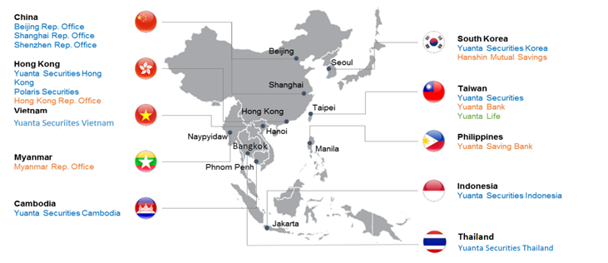

**YUANTA SECURITIES VIETNAM OFFICE**

**Head office:** 4th Floor, Saigon Centre, Tower 1, 65 Le Loi Boulevard, Ben Nghe Ward, District 1, HCMC, Vietnam

**Institutional Research**

|  |  |
| --- | --- |
| **Matthew Smith, CFA**  Head of Research  Tel: +84 28 3622 6868 (ext. 3815)  matthew.smith@yuanta.com.vn | **Binh Truong**  Deputy Head of Research (O&G, Energy)  Tel: +84 28 3622 6868 (3845)  [binh.truong@yuanta.com.vn](mailto:binh.truong@yuanta.com.vn) |
|  |  |
| **Tanh Tran**  Analyst (Banks)  Tel: +84 28 3622 6868 (3874)  [tanh.tran@yuanta.com.vn](mailto:tanh.tran@yuanta.com.vn) | **Tam Nguyen**  Analyst (Property)  Tel: +84 28 3622 6868 (3874)  [tam.nguyen@yuanta.com.vn](mailto:tam.nguyen@yuanta.com.vn) |

**Di Luu**

Assistant Analyst

Tel: +84 28 3622 6868 (ext. 3845)

di.luu@yuanta.com.vn

**Institutional Sales**

|  |  |
| --- | --- |
| **Huy Nguyen**  Head of Institutional sales  Tel: +84 28 3622 6868 (3808)  [huy.nguyen@yuanta.com.vn](mailto:huy.nguyen@yuanta.com.vn) | **Tu Nguyen**  Sales Trader  Tel: +84 28 3622 6868 (3890)  [tu.nguyen1@yuanta.com.vn](mailto:tu.nguyen1@yuanta.com.vn)  **Trung Nguyen**  Sales Trader  Tel: +84 28 3622 6868 (3890)  [trung.nguyen2@yuanta.com.vn](mailto:trung.nguyen2@yuanta.com.vn) |